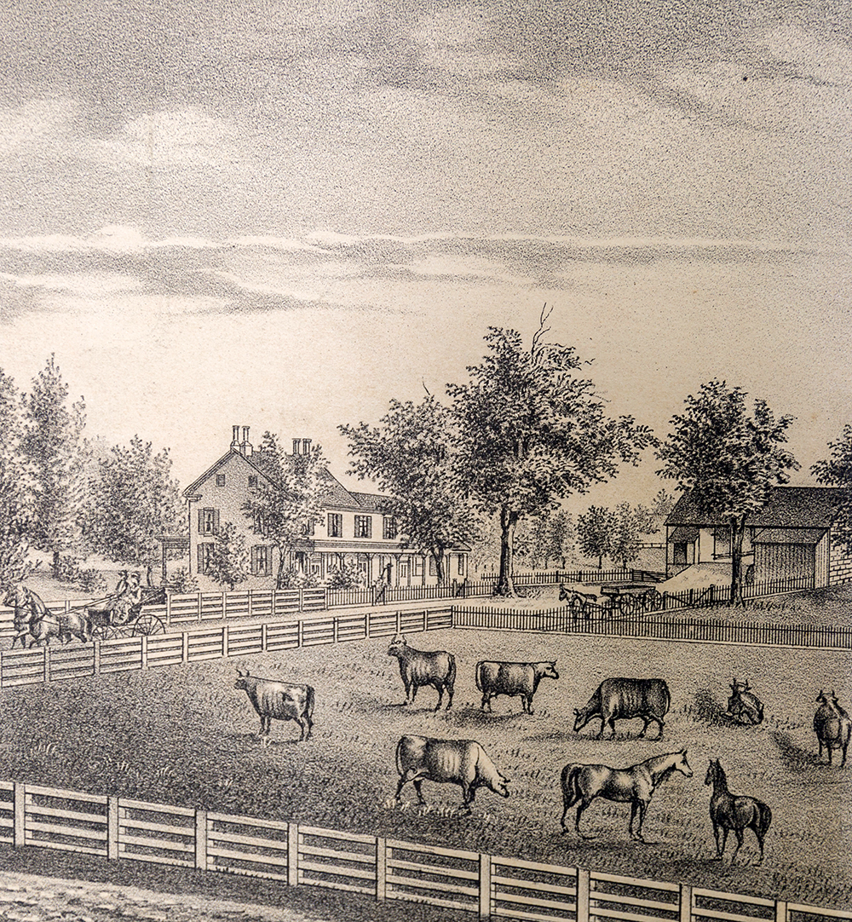

A Journey to the Past at
Penn State Brandywine
  - A Student/Faculty Research Project

Phyllis Cole and Students in American Studies
featuring the work of Larry Smythe Jr., Eileen M. Fresta, and Kevin Pistiner

Table of Contents
Introduction 1
The Pratts 4
The Painters 9
The Mill, the Emlens, and the Yearsleys 13
The Quaker Separation 18
Women 23
Cumberland Cemetery 28

Introduction
It is time to celebrate the future of Penn State Brandywine, with a new student union and residential housing scheduled to open in time for our fiftieth anniversary in the fall of 2017. But for that very reason it may also be time to discover the past: what was this place, this neighborhood, before it was ours? In the nineteenth century, on the very site of the student union between Vairo Library and Tomezsko, stood a stone farmhouse belonging to Thomas and Mary Worrall Pratt. This website is dedicated to reconstructing their world amidst their neighbors in Middletown Township, Pennsylvania.
The Pratts’ dairy farm was green and quiet, but part of a changing world. South of it in the 1850s ran Underground Railroad routes for fugitives from slavery, as well as a cluster of new mills for manufacturing cotton cloth. Dairy farming too had become a large, profitable business; as Larry Smythe, Jr. writes in his Penn State Brandywine thesis, Thomas Pratt was an “enterprising man” as part of it. In the 1850s he turned to producing ice cream that was served near the courthouse in the newly established county seat of Media; the recently constructed train lines could also transport it to further markets. Thomas had joined with Minshall and Jacob Painter, his nearby neighbors, in promoting this new town, even donating the trees that graced the courtyard square. Together they belonged to the Delaware County Institute of Science, also now established in Media and a sponsor of scientific knowledge of all kinds. Together they supported the social changes going on around them. Their enterprise extended widely.
In between the Pratts’ land and the Painters’ (now Tyler Arboretum) stood the old Friends Middletown Preparative Meeting House Middletown Preparative Meeting House where all these Quaker neighbors had come of age. But it had divided bitterly on both the local and denominational levels into Hicksite and Orthodox factions in 1827; the Pratts and Painters both went with the Hicksites before opting out of formal religious community altogether. The Pratts’ neighbors in the other direction—Humphrey and Catherine Yearsley, who operated the gristmill on Rocky Run serving all these farmers—sided instead with the Orthodox. In fact the previous mill-owner’s wife, Sarah Emlen, had for a time led in offering their property as an Orthodox meeting place. In 1860 Thomas Pratt made his own offering to a divided neighborhood, founding a non-sectarian cemetery named “Cumberland” on family land that extended between the rival meetinghouses on Middletown Road.
Not much remains of the Pratts’ farm itself—just a remnant of the springhouse that kept their dairy products cold, by the creek down the hill behind Main. Probably by 1860 the sycamore tree in front of Main had already sprouted toward its present-day grandeur; later farmers let it thrive as a single tree with cultivated land all around it, and today it reminds us of growth from past to present. Our campus founder, John Vairo, remembered the island of lilacs and fruit trees around the Pratt farmhouse when he first looked at the land in 1967. But the house itself was a ruin, the foundation eventually bulldozed as fill for our parking lot, and nearby trees remaining until 2016 have been sacrificed in campus expansion. In honor of the trees, our new residence hall is suitably named “Orchard Hall.”
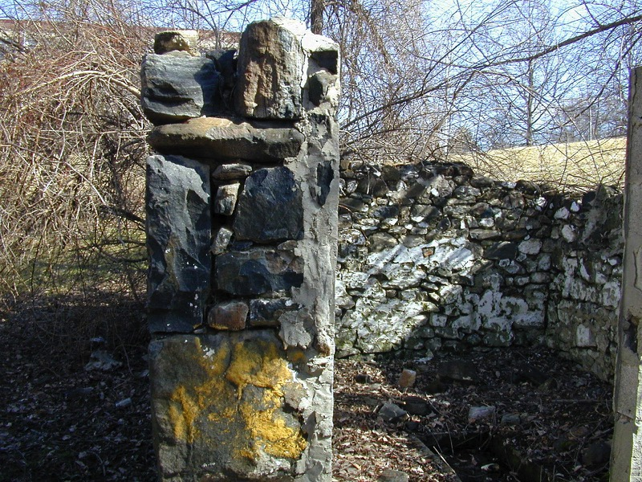
Figure 1: Remnants of the Pratt springhouse
Despite all changes, however, Penn State Brandywine today is part of a surviving historic landscape. We have purchased a section of the Emlen-Yearsley mill property, and its barn survives. So do the two once-opposing Quaker meetings, and between them Cumberland Cemetery. Two historic houses, fully restored and open to the public, are part of this story: the Painters’ at Tyler Arboretum, less than a mile from campus, and Thomas Pratt’s ancestral home at Colonial Pennsylvania Plantation in Edgmont. Most of all, these people survive through records of inheritance and dispute, newspapers reporting their triumphs and tragedies, and (for at least some) letters and diaries telling the story in their own words.
Over the past sixteen years, Penn State Brandywine American Studies students and faculty have often dug into this local treasure trove, and now we would like to share the results of our collective labor with the campus, university, and community. Research by undergraduate students has made the project possible: in particular Schreyer Honors theses by Larry Smythe, Jr. and Eileen M. Fresta; independent studies by Gloria Boyd, Virginia Livanos, and Kevin Pistiner; internships by Eileen M. Fresta and Shannon Crowe; and student projects throughout this time in Phyllis Cole’s AMST 491 classes on “American Lives.” Students of Larry Smythe and Laura Guertin have contributed further. Administrators George Franz, Kristin Woolever, and Lisa Marranzini have always been supportive, and Bill Tyson has taken up the work of creating this website for the campus from our text.
Finally, Brandywine’s American Studies program would like to acknowledge the indispensable help and response of our neighbors in carrying out this work: on the institutional level, Tyler Arboretum, Colonial Pennsylvania Plantation, Delaware County Archives, the Cumberland Cemetery Company and Monaghan Family, the Middletown Historical Society, the Delaware County Historical Society, Haverford College Quaker and Special Collections, and Swarthmore College Friends Historical Collection; among many individuals, Esther Darlington, Jared Darlington, Leslie Potter, Mary Anne Eves, and Pamela Harper. In May 2017 the Delaware County Institute of Science graciously hosted a presentation by Smythe, Pistiner, Fresta, and Cole that was the personally interactive forerunner of our website. Thanks to all.
We will tell in turn of the Pratts, the Painters, the gristmill families, the Friends’ Separation, the silent (and not-so-silent) women of this patriarchal society, and the Cumberland Cemetery. It is tempting to call these people ghosts on our campus, especially with that cemetery so nearby. But call them instead presiding spirits, venturesome people for all their flaws, who valued education and engaged in their local and national communities. They are good ancestors to this campus of Penn State University.

The Pratts
Thomas Pratt (1818-83) grew up on the farm in Middletown that is now Penn State land, assuming full ownership at the age of twenty-one in 1839. As the research of Larry Smythe discovered, Thomas signaled his adulthood in other ways as well that year: he joined the seven-year-old Delaware County Institute of Science, declaring his commitment to knowledge and natural history, and he married Mary Worrall (1817-70), daughter of a nearby farming family with shared roots in Middletown Friends Meeting. But the young couple was married by a civil magistrate rather than the Quakers: her family had left the meeting, and though to that point Thomas was still considered a member, his marriage and increasing distance made the Orthodox question his membership in their fold. Thereafter the Pratts apparently attended neither religious meeting.
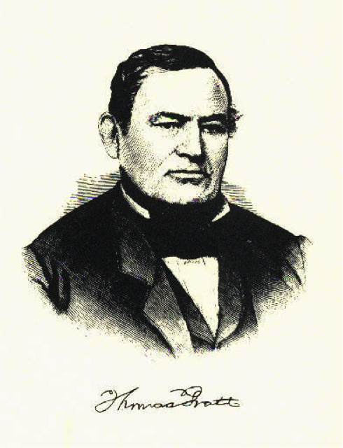
Figure 2: Thomas Pratt
Thomas’s ancestors had come to Pennsylvania in 1682, part of William Penn’s first generation of settlers, and after three years as indentured servants they became landowners. From modest beginnings arose prosperity, through the careful cultivation and transmission of land. Four generations lived on the farm in Edgmont that is known today as Colonial Pennsylvania Plantation, which brings the eighteenth-century Pratt household, fields, and farm animals to life for visiting history lovers. Thomas Pratt, the father of our Thomas, grew up on this farm but did not inherit it. In fact his eldest brother Joseph, who did inherit, may have precipitated the end of the family’s ownership in Edgmont. After fathering an illegitimate son as well as legitimate heirs, he died young and eventually forced the next generation to sell their farm. Future Pratt prosperity would lie elsewhere, including with younger brother Thomas.
Established by his parents on another property in Marple, Thomas raised one family there, then as a widower married again to Hannah Heacock of Middletown, becoming owner of the farm she brought with her from a first marriage. This is the land now owned by Penn State. At the remarkably advanced ages of 56 and 52 respectively (if the records can be believed), they gave birth to one child, Thomas, in 1818. Father Thomas died just two years later, and doubly widowed Hannah shouldered the responsibility of raising her young son.
She did not do so alone, because she had lived her life in a community knit together by blood, religion, and economic interest. Related to the wealthy Minshall family, she reached out to make Enos Painter, the Minshalls’ heir and entrepreneur, her son’s guardian. Painter sold off the land outside Middletown that young Thomas had inherited, leaving the boy with the significant sum of $1828 to make his start in life. These families were linked as well through the pre-Separation Quaker community, its meetinghouse directly across the road from the Pratts’ farm, where Monthly Meeting records included Hannah and the child Thomas as members alongside the Minshalls, Painters, Emlens, Yearsleys, Worralls, and Darlingtons. Enos Painter at one point was appointed by the meeting especially to care for the schools that their religious society sponsored. The school that both the Pratt and Painter families chose for their own children was Westtown, the recently founded coeducational boarding school (still in operation today) that led Quaker education regionally in its effort to develop learning and piety in the young.
Thomas and Mary Worrall Pratt wasted no time in developing their own household and farm operation after marriage in 1839. Mary’s part was the traditional one of reproduction and child raising: two daughters and four sons were born over the decade following. She probably also played some part in dairy farming, since milking cows, producing butter, and even selling the products was considered women’s work. The springhouse by the creek was primarily her space, along with her daughters and women servants.
Dairy farming, however, also grew in commercial scale in these years; as one nearby observer wrote, the farmer turned his operation into a “butter factory” and became “his own dairymaid.” The Darlington family, west of the Pratts in Middletown, started by 1840 to gain a national reputation for their butter, eventually sending it even to the White House in Washington by railroad car from a station on their land. Thomas Pratt’s specialty was ice cream, shipped by boat from Chester to Philadelphia. As Delaware County historian Henry Ashmead claimed, Pratt pioneered in its manufacture, and “the enterprise proved so profitable as to have induced many others to embark in the business.” At the Delaware County Institute of Science Annual Autumn Exhibit in 1848, Pratt exhibited eight flavors and won first prize for lemon. He and his partners also showed an entrepreneurial spirit by advertising. As the ad line proclaimed in the 1860 Delaware County American,
Ice Cream! Ice Cream! Ice Cream! Wm. Beeby having made arrangements with Thomas Pratt, of Middletown, for a constant supply of ice cream during the season, than which there is none better in the market, invites the attention of the public to his saloon on South Avenue, Media, Pa.
The new county seat was well supplied with the new favorite dessert.
Meanwhile, throughout the 1840s and 50s, Pratt acquired additional property with his profits and joined others in protecting the interests of economic development. He expanded his single farm along the western side of Middletown Road to three, while land inherited by his wife on the eastern side of the road added still more to the family holdings. He bought into the new incorporation of Media in 1849, acquiring property just north of the courthouse and its hub of political power; eventually he retired to a house there. He founded and became president of the Delaware County Mutual Insurance Company, based in Media, and from 1855 to 1858 served as a County Commissioner. A wealthy man by 1860, having doubled his assets over the past decade, he could turn his three farms over to three surviving sons and construct a new and elegant parental country house (still surviving today as a private home), across and back from Middletown Road. The marriage of two Pratt daughters to Darlington sons guaranteed their futures and further consolidated family interests. The man who, in 1860, began to develop a cemetery on the eastern side of the road could afford to be generous to his community, though this was also a source of potential profits.
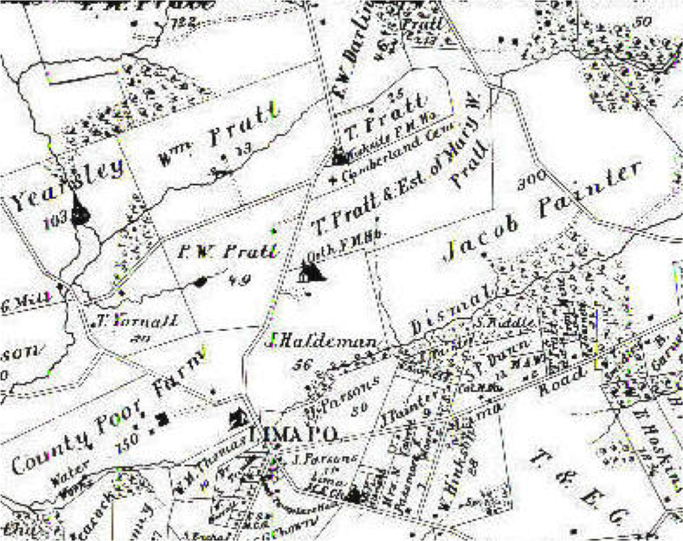
Figure 3: Middletown Township, founded 1686
But there was internal conflict in this family, conflict having to do with the cemetery property and more. Mary Worrall Pratt’s view of her husband’s career was essentially negative, because she felt unjustly excluded from his profits as a landowner. We can know this from the remarkably detailed court records and news reports of a lawsuit initiated by her two daughters, now both Darlingtons by marriage, after the deaths of their parents. Mary died in 1870 and William remarried in 1874, to Sarah Johnson. Then, when he in turn died in 1883, he left most of the estate to this second wife, at which point the children of his first marriage claimed a right to more of the $30,000 property. As Mary’s brother Sharpless Worrall testified, by the specifications of their parents’ will a substantial amount of capital and land—including the seventy-two acres of which Cumberland Cemetery was part—had been rightfully inherited by Mary but “taken” from her by Thomas Pratt. In dealing with matters of inheritance, Thomas would force Mary to sign power of attorney forms over to him, and she signed. “Thee knows what unkind treatment I have received,” she told her daughters in Thomas’s hearing. “I must sign for peace.” Even when she asked for her profits he refused. “It was a constant source of trouble between them,” eldest daughter Elizabeth concluded, “and during the last years of [my] mother’s life they lived very unhappily.” The 1875 map of Middletown recognizes this double claim, specifying that the land between the two Quaker meetinghouses belonged to “T. Pratt & Estate of Mary W. Pratt.” Who was right? As we will see further in the section on Women, Thomas Pratt was doing no more than other husbands had traditionally done. Claiming property through marriage was a given of patriarchal society. Yet law and custom were changing, and women’s expectation of independent ownership rising.
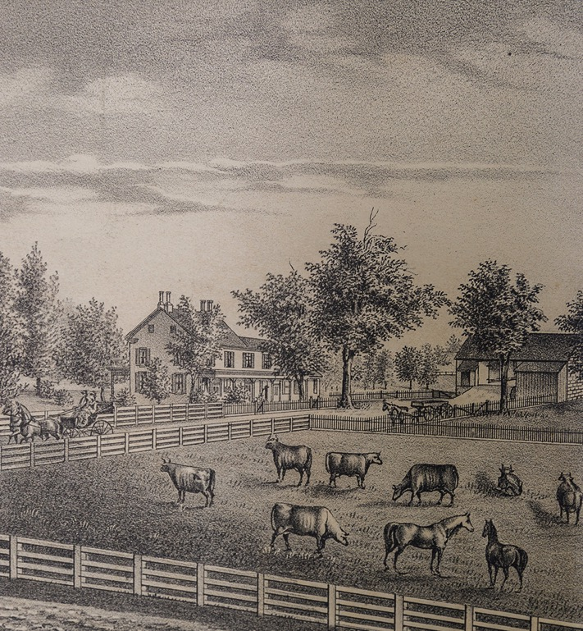
Figure 4: Drawing of Pratt Farm circa 1875
Thomas and Mary Pratt were part of their times in both conflict and accomplishment. Barring the discovery of a new cache of private writing, we cannot know more about this strong-minded wife. Even Thomas’s opinions are largely unstated, his record of accomplishment speaking for itself. But that is clear on the public record. He excelled not only in capitalism but in the benevolent social developments that it could make possible. Though disaffiliated from the Society of Friends, he translated its strong value on social justice and progress to public form. He was an Abolitionist and, by 1860, a Republican. Service on the Middletown school board acted upon the Painters’ Quaker commitment to education in the broader sphere of secular society. The movement against abuse of alcohol drew his strong support, and from 1850 on he served as a manager of the Charter House, a temperance hotel in Media. In 1859 he helped found the Pennsylvania Training School for Feeble-Minded Children, becoming a life member of the school in Middletown known today as the Elwyn Institute. And his establishment of Cumberland Cemetery a year later should be seen as part of the same public service. We have to accept the irony that it was on land that he took from his wife without her consent. There they are buried side by side, their children and neighbors around them.
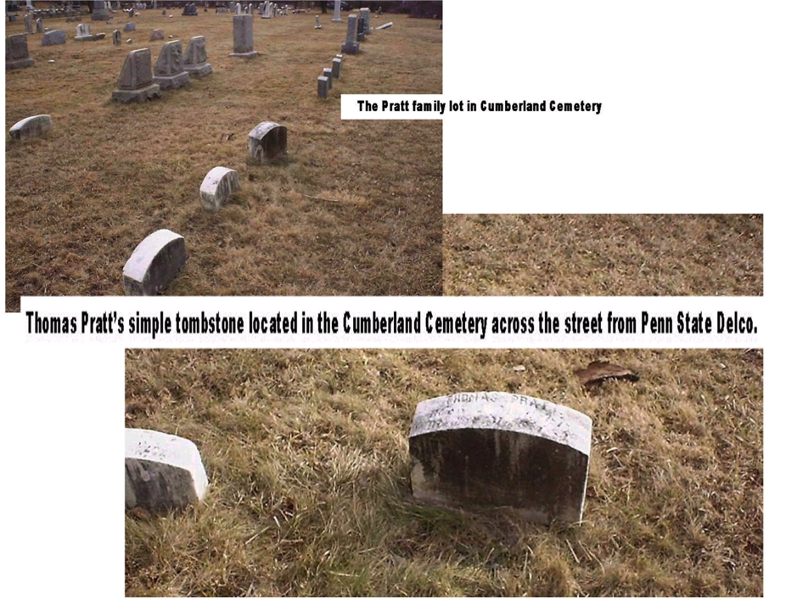
Figure 5: Pratt family burial plot

The Painters
Tyler Arboretum, less than a mile from Penn State Brandywine, is a 650-acre garden and environmental education center that celebrates the trees and other plants cultivated over half a century by Minshall and Jacob Painter (1801-73, 1814-76), farming brothers whose wealth allowed them to turn from profit-making production to horticulture. But Tyler is also a family farm, its historic house (Lachford Hall) a time capsule that takes visitors back to the brothers’ era and beyond. First built by the Minshall family in 1738, on land that was theirs since 1681, it became the Painter homestead when Hannah Minshall, the only child of her generation, married Enos Painter in 1800. Its neighbor in Edgmont, Colonial Pennsylvania Plantation, is a working farm reconstructed with historically accurate furnishings in the twentieth century to bring an earlier time to life. By contrast, Lachford Hall at Tyler Arboretum contains the Minshall-Painter-Tyler family’s actual household goods and furniture as they were left when the last residents departed. Both houses have distinct sections marking growth from one generation to the next. Both are linked to Penn State, the Plantation as Thomas Pratt’s ancestral home and the Arboretum as a hub of activity by his mentors and allies, a place he would often have visited.
The Painters were remarkable in their preservation of words as well as things: in addition to their surviving tree specimens, house, and on-site library, the family kept a vast archive of business accounts, scientific observation, historic reminiscence, letters and diaries, and even school notebooks, all of which are accessible today in the Swarthmore Friends Historical Library at Swarthmore College. In recent years both Tyler and Swarthmore have welcomed Penn State American Studies students to explore these scenes and archives, and what we have to say about the family builds on such discoveries. Though the eminent brothers have always focused our interest, we have also looked at them within a broader network of family members and neighbors across gender and generation.
So we begin with the parents, Hannah and Enos (1782-1838, 1773-1857): she the key to preserving her family lineage, he (an apparent outsider from Chester County, trained as a hatter) the agent of growing prosperity. If they followed the usual courtship patterns of the Quakers, the young people chose each other, but with parental approval as an important framework. Hannah had transcribed the humorous “Advice to Choose a Husband” into her school commonplace book short years before their marriage in 1800: “Please thy parents if thou can/Be sure thyself to love the man.” As far as we can tell, all apparently gained in this union. Hannah’s widowed father lived in the house another seventeen years but was able to turn over farm management to Enos, instead taking care of his beloved fruit trees and the nearby Quaker burial ground. Hannah gave birth to seven children from 1801 to 1818, far surpassing her mother in reproduction. Enos succeeded brilliantly as a businessman. If we walk into the Painters’ kitchen today, the tools and treasures of this generation are still visible: spinning wheels, a container for cream to rise from milk, an imported Chinese tea caddy. The item that best represents Hannah is a high chair, probably hers in childhood and certainly crucial to her motherhood. A secretary represents Enos: it originally belonged to Jacob but became his own desk; inside it today, as if tucked away from an evening of figuring, is one of his account books of the farm.
Eldest son Minshall Painter, a family historian as well as scientist and civic leader, offers enough life history of his parents to bring the high chair and secretary to life. Hannah “received for that period a liberal education” but lived within her home sphere, “a woman of exemplary habits and very much devoted to her children.” Enos was not himself “a very extensive agriculturalist,” but instead rented out his lands for tenants to farm, built an enormous stone barn to house his dairy business, and himself focused on increasing land holdings. Soon he had restored the former amplitude of the Minshall estate and acquired more property outside, as well as running a sawmill on the home property and investing in the coal and navigation industries.
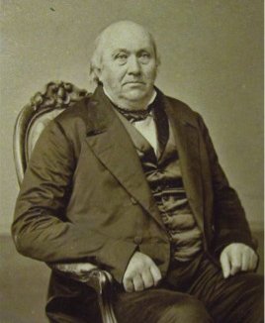
Figure 6: Minshall Painter
All of these elders, in their respective styles, lived their lives as neighbors and supporters of the Quaker meeting. Grandfather Jacob dug graves in the burial yard, kept interment records, and freely invited strangers home after meeting. Enos oversaw the Quaker school nearby. But when the Separation took place in 1828, the Orthodox accused him among others of actively promoting it. Enos was clearly a contentious person. After a dispute with fellow Quaker Jesse Reece over repair of a fence between their properties, he was finally disowned by even the Hicksite meeting in 1840 and won reinstatement only through appeal to the state Supreme Court. His sons, however, opted soon thereafter to leave Quaker affiliation behind. Wife Hannah grieved rather than fought over the division in her community. In 1828, as Minshall wrote, she went with the “more liberal party” but was “most severely tried by being separated from some of her more intimate fellow members who inclined to go with the other party.” She remained a Hicksite, dying ten years later (before Enos’ fence dispute) of a stroke that actually came upon her in meeting. Quaker simplicity allowed for no grave markers. But, as Jacob wrote in a later poem, the fond sons planted a magnolia tree at her burial site, and, “When death released [Enos] after four score years,/ We laid him by her side.”
Minshall and Jacob, however, did not in death join their parents at the Quaker burial ground, but instead had elaborately carved stone mausoleums built for themselves at Cumberland, just the other side of the wall from Enos and Hannah. The last lines of Jacob’s self-composed epitaph describe both brothers: “From nature’s laws he drew his creed,/ As taught by nature’s god.” Their devotion to cultivating the natural landscape was based on a larger study of science, begun even before the Quaker division and later controversies took them away from the meetinghouse. Neither brother described the beginning of this fascination, but an entry in Minshall’s diary offers a glimpse of his turn from farming to observing nature. After a day of threshing fields and carrying wood in 1824—with Father (perhaps significantly) absent delivering cider—the young man observed a meteor descending towards the east: “and just before it disappeared it divided into two from the place where it began…and its height from the horizon would make an angle of about 20 degrees.” His impulse to measure and record scientific phenomena would long continue; even more than the Quaker Separation or his father’s disputes with the meeting, this was the positive impulse requiring independence from religious doctrine.
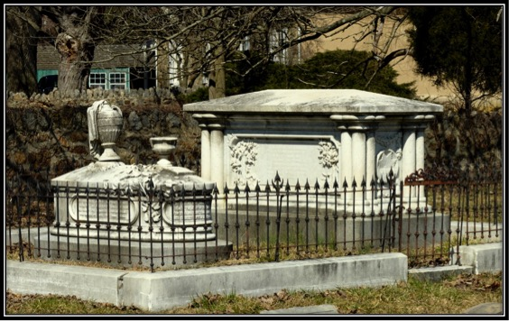
Figure 7: Painter brother's mausoleum
Minshall’s passion for science, assisted by his much younger brother Jacob, is writ large in two Delaware County institutions that should really be visited side by side. At Tyler Arboretum the brothers planted over a thousand trees and plants, many of which survive today amidst the acres that have been planted since their lifetimes. Their goal was scientific observation, not mere adornment. The library that they built in the 1860s was the setting for such study, housing not only books but a mineral collection, microscope, telescope, camera, and printing press. All of these things were of a piece with the Delaware County Institute of Science, still open today on Veterans’ Square in Media as a museum and center for what the nineteenth century called the “diffusion of useful knowledge.” Minshall choreographed its activities, gave lectures himself, and left many papers to the Institute. At their fairs, while Thomas Pratt won prizes for his ice cream, Jacob displayed twelve varieties of apples from the Painter farm.
It is important to realize, however, that the Painter family’s learning did not belong to the two brothers alone. All seven of the children of Enos and Hannah, girls and boys alike, were educated through the secondary level, directly following their mother’s example. In 1836 youngest sister Ann expressed thanks to her chemistry professor at the West Chester Boarding School, and in return he told of his passion for teaching chemistry specifically to women, since it would both serve practical purposes and ascend “the sublimest heights of Philosophy.” Jacob was the first family member to attend college, Rensselaer Polytechnic in Troy, New York. But members of the next generation followed suit, as new kinds of higher education became available. Ann’s son William attended the Pennsylvania Agricultural College (Penn State); her niece Helen Barnard, apparently with Ann’s financial support, graduated from coeducational Swarthmore and afterward trained as a nurse.
In their turn from the Quaker meetinghouse to secular science and knowledge, the Painters were not abandoning community but enlarging it. This was a family of doers. Their sister Sarah and her husband Eusebius Barnard, in Chester County, were the family’s most committed antislavery activists, but at least once a fugitive slave was harbored at Lachford Hall. Jacob’s signature cause was the women’s rights movement; he both attended the 1851 convention in Massachusetts and helped plan its 1852 sequel in West Chester. Minshall transferred the family support of Quaker schools to the growing public system; he argued for removal of the county seat to Media and gave the new town its name; he led in making it not only friendly to reform, but itself an act of reform. He was a county leader, both on his own and in league with Thomas Pratt.

The Mill, the Emlens, and the Yearsleys
In 1902 the Chester Times commented on a historic mill in Middletown, now “crumbling to ruins,” that deserved repair. “From it came a great deal of the flour shipped to the American soldiers during the second war with England.” This was Yearsley Mill, which Penn State Brandywine knows today only through the road name in our address. In 2013, however, we purchased twenty-one acres extending campus property the length of Yearsley Mill Road to its intersection with Old Forge Road. And by so doing we acquired the aged barn for the mill itself, once located on the opposite side of Old Forge. Two privately owned, surviving houses complete the complex, the miller’s home just north of the mill and a second house at the southeastern corner of the intersection. All of these places have stories to tell of the hundred years and more from James Emlen’s purchase of the property in 1784 to Humphrey Yearsley’s death in 1887.
America’s soldiers in the War of 1812, who often embarked from Chester, are quite likely to have eaten bread made from this mill’s flour, but there was also competition to supply them in the neighborhood and region. An 1826 survey of Delaware County lists twelve grist mills—mills grinding wheat and corn—in the valleys of Chester Creek and its tributaries alone. Other mills on the creek allowed owners to saw wood, make paper, cut metal, and spin cotton (the last creating a manufacturing boom in its southern part by this time). The power of a creek could turn water wheels for many purposes, in either agriculture or industry. But the grist mills of the Delaware Valley dated from colonial times and really led to the others. Throughout the eighteenth and nineteenth centuries southeastern Pennsylvania was the “granary of America.” Its hot summers allowed for three crops a year, and its vast network of creeks produced not only lush fields, but the means of processing grain from them. Even after dairy farming took over as the leading form of agricultural production, grain remained crucial as feed for the animals.
Today we can both see the technology and feel the beauty of such places by visiting Newlin Mill, a working historic mill near Concordville, just four miles from campus. The Newlins’ operation, on the western branch of Chester Creek, was eventually twice the size of the Emlens’ and Yearsleys’ on Rocky Run, another branch of Chester Creek. But the two mills were similar in structure; in fact a 2001 state archaeological study describes Yearsley Mill by comparing its remains with Newlin’s restored system. A two-and-a-half story structure housed the operation of the mill, which was built into a hill. A dam and secondary canal, known as a mill race, connected to a small lake on the opposite side of the road (the land Penn State now owns). The mill race supplied a steady flow of water, which was diverted from Rocky Run and regulated to turn the wheel more efficiently. The elevation of the hill against the mill provided additional power as the water fell from the peak of the hill onto a wooden wheel that powered the grinding process. Even Pratt’s Run, the small creek that crosses today’s campus, fed into the water system. Shafts and gears connected the wheel to a turning stone placed on top of a stationary stone, each a circular disc four to six feet in diameter, onto which grain was fed for grinding from a hopper above the structure. As the top stone turned against the stationary stone, grain was slowly converted into flour that seeped out from between the stones.
This mill was first built and operated thirty years before the American Revolution, but an unlikely man became its owner in 1784. As the research of Kevin Pistiner reveals, James Emlen (1761-98) had grown up in Philadelphia, the son of a wealthy Quaker brewer with a townhouse on Chestnut Street. But James felt a spiritual calling that led to his repudiating business and European travel in favor of retreat to the country. At his kinswoman’s gristmill in New Garden (near Kennett Square), he learned the milling trade and served the community without asking for pay. Soon he bought the mill in Middletown, living there the rest of his life. The estate of £3975 that he left behind (more than $500,000 today) shows that he did not live meagerly, still keeping the fine furnishings that a Philadelphia businessman might be expected to have. And apparently he did not himself run the mill, as the 1798 will specified that his “good friend Nathan Yearsley [should] have the preference as a Miller to my Mill…either on the shares as he now has it or at a very moderate rent.” Yearsley was Emlen’s tenant. Instead the mill was a site for Emlen’s effort to realize the contemplative ideals of the Quaker religion: in his biographer’s words, Emlen sought out “mental retirement” and “embraced the ancient simplicity of the true believer.”
In fact we can know in some depth about two generations of Emlen men, because later in the nineteenth century the Orthodox Quaker press made positive moral examples of them. As their biographies separately tell, James Sr. (1760-98) and his youngest son, James Jr. (1792-1866), both became elders of the meeting before their thirtieth birthdays. Both resisted the temptations of affluence for relative simplicity, the younger foregoing the fashionable hairstyle and worldly speech of his youth and returning to the Quaker “Thou” in conversation. Both lived by the mill in Middletown but did not run it; both lived a family life based on egalitarian marriage and devotion to children. James Sr. married Phebe Pierce of Thornbury and “lived in endeared fellowship of spirit” as they produced six children, whom he gathered around him on First-Day (Sunday) afternoons for Bible reading and conversation. James Jr. married Sarah Farquhar, a minister in the Society of Friends, and with her raised seven children amidst both parents’ travel and teaching. The Friend, an Orthodox periodical, offered the son’s biography first, then some years later the father’s as “very similar in character”.
This similarity is all the more interesting because the younger James hardly knew his father. Both of his parents had died by the time the boy turned six. Raised by his mother’s parents in Thornbury and educated at Westtown School, he seems to have consciously returned to the place in Middletown where his life began. The circumstances behind this family history are dramatic. Both James Sr. and Phebe had been appointed as representatives to the Friends’ Yearly Meeting in Philadelphia, where a yellow fever epidemic was raging in 1793. Despite their six children at home, despite knowing they courted death to go into the city, both attended. Phebe became ill and quickly died, and, accepting this sad outcome with “perfect resignation to the divine will,” James took up the sole care of his children. Five years later he again felt the duty to attend Yearly Meeting, and this time it was he who succumbed to yellow fever. In recognition of the risk, he wrote his will before departure, appointing guardians over his sons and daughters and leaving all property for them to “share and share alike.” It was also now that he gave Nathan Yearsley first right to rent the mill and bequeathed a hundred pounds to the founding of Westtown School.
Though Emlen cherished his children, religious service was an even more imperative calling. And it was significant service, not a mere gesture of self-sacrifice, by a leader held in the highest esteem. In 1794, less than a year after Phebe’s death, he joined three other Philadelphia Friends appointed for a month-long trip to Canandaigua, New York (near today’s Rochester) to represent principles of peace in a treaty negotiation with the Iroquois Six Nations. Emlen’s detailed diary of the month-long trip tells of arduous travel by horseback through a Pennsylvania and New York wilderness now filling with American settlers. He balanced between sympathy for these isolated Americans and openness to Native American resentment against them. “We hope you will…be redeemed from the Spirit of War and cherish peace,” he records from the Friends’ address to the Iroquois. “We wish that when you apprehend yourselves aggriev’d you would make your grievances known and not seek to revenge them.” Returning home, he joined the Yearly Meeting’s first standing committee on Indian affairs. When he travelled into fever-threatened Philadelphia a few years later, he was going on business to the nation’s capital and center of Quaker peace principles.
A generation later, James Jr. and his wife Sarah served the Society of Friends as well. They married in 1816 and soon after moved to Middletown, James buying out his siblings’ shares of the mill. James and Sarah opted, however, to live in its second, smaller house on the corner of what are now Old Forge and Yearsley Mill Roads. At first intending to farm, James soon turned to his truer vocation and established a school for boys alongside the house. Sarah may have joined in this teaching, since she had come from a recent period teaching at Westtown; in fact the couple, both onetime students there, almost surely met through the school’s community.
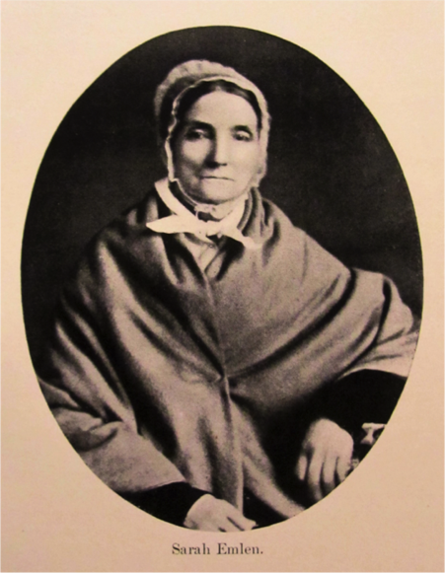
Figure 8: Quaker Minister Sarah Emlen
As a Quaker elder and officially designated minister respectively, James and Sarah led busy lives. Starting to have children right away, Sarah also continued her traveling ministry, first telling how she missed her infant just a year after marriage. Both the expressions of love and the travels would continue. In 1825 she undertook a five-month preaching trip to the meetinghouses of New York and New England, leaving a housekeeper to assist with the five children. But she always counted on James to take responsibility for them as well, once giving meticulous instructions to him about how the older daughter should measure her sisters’ heads (“round a little above the ears”) for their new bonnets. And were they all behaving and doing well in school? Parental conversation also flowed when James was travelling on behalf of the meeting. In 1828 he journeyed to the South and Midwest while Sarah remained at home; now her “fireside talk” by letter told of garden plantings, baby-talk by their “very clever” children, and local turmoil in the meetinghouse.
“The way is opening very fast for us to meet in the Schoolhouse,” she wrote to James that August. As the next chapter will say in more detail, Sarah played a direct role in leading the Orthodox in their crisis, offering the Emlen school by the mill as an alternative meetinghouse. This arrangement sufficed until 1835, when a new meetinghouse was constructed (still in active use) on Middletown Road. But then James seems to have taken the lead in moving the family back to their older common ground, Westtown School, for a new phase in his teaching career. For another fourteen years James was cherished for the words of wisdom that, as a writing teacher, he inscribed in students’ “albums,” while Sarah undertook new and ambitious preaching journeys.
Meanwhile the Yearsleys, with or without the Emlens as neighbors, ran the mill on Rocky Run. We can chart their lives only through public documents, not the manuscript archives and retrospective biographies allowing the Emlens to be known more fully. The outlines of their story, however, are still clear. Nathan Yearsley (1762-1825) was the active miller when James Emlen Sr. died in 1798, and he gradually rose from tenant to proprietor. By 1802 he owned at least the gristmill and thirty acres, since he was taxed on this property by the county from then on, and finally in 1823 he bought the main house and its hundred acres from the Emlens. He seems to have been a man on the rise, and it would have been he who sold flour to the army in the War of 1812.
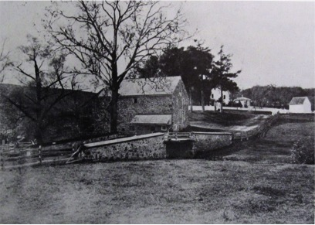
Figure 9: Emlen Property circa 1865, Yearsley Mill and Old Forge Rd.
Nathan also married in 1812, to Tacy Hill (1765-1839), and though this was a late marriage for both, they had one child, Humphrey (1815-87). Quaker meeting records show the family as members worthy of responsible offices, Tacy among those representing Middletown at Monthly Meeting in 1814, Nathan appointed to help the local community raise money in 1825. But later that year he died, and Tacy was left with a ten-year-old to raise. We can only speculate about her conversations with neighbor Hannah Pratt, who was going through the same trial of widowhood with her slightly younger son Thomas. Father Nathan had died without a will; however, a guardian was appointed for Humphrey and a miller hired to run the mill until the boy reached maturity. The family seems to have remained prosperous: the court’s inventory of Nathan’s estate showed him with household goods intact and $3060 of fees ready for collection. The spare language of tax assessment reveals what Humphrey subsequently owned at twenty-one in 1836: one house, one barn, one springhouse, one grist mill, two horses, two cows, four steers, and two oxen. The next assessment after that added two dogs and (a clear sign of status) a gold watch. In the Quaker Separation, both Tacy and her son had remained with the Orthodox community; and when she died in 1839, the news article announcing her death declared her a “member of the Society of Friends,” resident in her son’s home.
After Humphrey married Catherine Water (1819-?) in 1837, three daughters joined them, and the Yearsley family seems to have sustained its middling status in the community. County newspapers listed Humphrey among supporters of a temperance hall for the village of Lima, Catherine on the committee planning a Ladies’ Fair at the Delaware County Institute of Science; these were causes held in common with their neighbors the Pratts and the Painters. And when the carriage horse bearing Catherine and her daughters took fright and ran wild, threatening an accident that was averted only by a gallant gentleman’s rescue, the perilous story was deemed worthy of news coverage.
Nonetheless, this generation of Yearsleys did not thrive amidst the increasing scale and commercialization of agriculture around them, which must have rendered their small mill operation less than competitive. As early as 1842, Humphrey was manipulating his economic status by temporarily setting up the property as a trust for his wife; this move does not suggest financial authority for the woman, but a shelter from debt for the man. The federal census shifted from listing him as “miller” in 1850 to “farmer” in all subsequent decades, with the mill perhaps only a subordinate part of his work. In 1870 rainstorms, amidst damage to the whole valley of Rocky Run and Chester Creek, swept away the Yearsleys’ mill dam and bridge, and Humphrey may never have recovered from such losses. Six years later he acquired a $20,000 mortgage on the property through his wife and daughter. He died in 1887, like his father leaving no will, but unlike him owing debts at a level requiring sale of all his real estate. Catherine could claim only a $300 widow’s exemption, and the court document listing her choices of what to retain makes even the language of estates poignant. As well as household furniture and a corn sheller, Catherine chose “Horse Dave,” “Cow Clover,” and “Heifer Blossom.” Her farm animals were individuals with names. We can hope that she and they continued their lives in the household of a daughter.
The mill property’s history after Humphrey Yearsley’s death offers strong evidence of the region’s commercial development, the force with which he could not compete. After several shifts in ownership, George Wood bought the property in 1901, part of the 1000 acres he acquired in Middletown as tenant dairy farms supporting the corporation that by 1922 became Wawa, the region’s largest supplier of milk products. Clearly he had no interest, as the Chester Times reporter of 1902 thought he should, in repairing a mill not part of such productivity. Wawa kept the property until 1945, then sold off these land holdings to private owners. The old barn that Penn State has acquired reflects all parts of this history. The construction of its core shows eighteenth-century origins, around which is nineteenth-century space for dairy production, the remnants of either Humphrey’s diversion to farming or the tenant farms that supported Wawa.

The Quaker Separation
There are two Friends’ Meetings on Middletown Road (Route 352) near Penn State Brandywine today. The easily visible one, as drivers head north from Route One, is on the right just before Cumberland Cemetery: this is “Middletown Monthly Meeting,” the once- Orthodox house, built in 1835. To see the second, park your car and head diagonally to the right by foot on the grass walkway just past Cumberland, across from the intersection with Yearsley Mill Rd. Directly ahead and off to the right, off of Old Middletown Road, is “Middletown Preparative Meeting,” first established in 1698 and occupying its present building since 1770; this is the once-Hicksite house. Even though the division between Hicksites and Orthodox has been healed since the 1930s, the two communities in this town and many others have continued to meet independently.
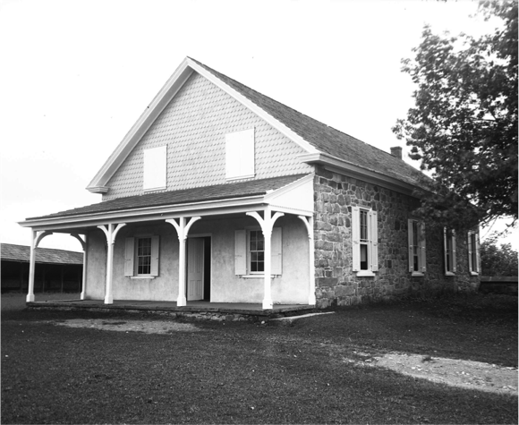
Figure 10: Middletown Preparative Meeting House
The Preparative Meeting is less than fifty yards from the parking lot of Penn State Brandywine, but few from this campus are aware of its existence. Those who discover it across Rt. 352 might feel they are stepping into another time, its burial ground framed by eighteenth-century stone walls and covered by grass that, well into the twenty-first century, was cropped by sheep that emerged from the long shed behind it. It is a quiet place. But this has been a scene of human conflict, where Middletown’s part in the division of Hicksites and Orthodox took place in 1827 and 1828.
It is also part of our neighborhood portrait. In May 1828, minister Sarah Emlen led an exodus from the old meetinghouse of all the Orthodox—representatives not only of Middletown but also of Chester, Providence, and Springfield—who had expected to hold their Monthly Meeting there. Upon arrival they discovered that the Hicksites were locking them out. Sarah presided over the crisis, and half a century later the Orthodox still remembered her leadership: “They gathered about the stone horse block in the yard, upon which our late Friend Sarah Emlen appeared in supplication”; then, feeling divine support, they departed to meet at the Emlens’ nearby house. To do so, the Orthodox and their horses would have taken Middletown Road to the southeastern corner of the Pratt farm, then turned on Yearsley Mill Road until it intersected with Old Forge Road. All the way they were bordering land now owned by Penn State Brandywine.
This incident also points to the larger question of how Separation could have come about among a peace-loving people. Quaker belief and practice were founded by George Fox in seventeenth-century England and brought to the new world by William Penn. Quakers affirmed that an “inner light” revealed God directly to every individual; and accordingly, their meetings (with no liturgy or Bible-reading) moved from universal silence to speaking by anyone who felt called upon to share his or her illumination of thought and spirit. At the same time the Quakers wanted no chaotic excess of speech and opinion. They were explicitly a “Society of Friends,” and there was a systematic ordering of local meetings into monthly, quarterly, and yearly gatherings among localities to share and decide policy. The Monthly Meeting that Sarah led in Middletown was part of this system, but it was dealing with dissent that had come upon the Philadelphia Yearly Meeting in April 1827.
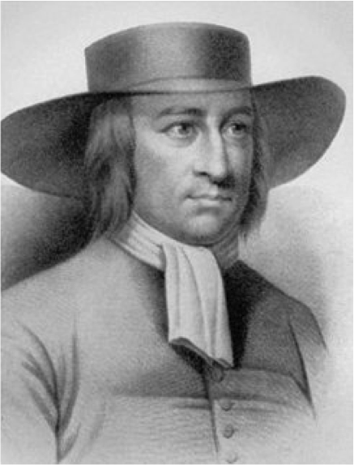
Figure 11: George Fox, founder of the Quaker religion
There, followers of Elias Hicks, a Quaker minister from Long Island, had protested that their faith in the inner light was being overwhelmed by more traditionally Christian belief oriented toward the Bible, salvation through Christ, and the authority of wealthy Philadelphia merchants. Rather than arguing, the Hicksites “separated” and claimed to constitute the authentic yearly meeting. In return, by the fall of that year, the Orthodox began to “disown” Hicksites by individual name from their meetings at every level. In both cases the groups seem to have hoped that distance would prevent open conflict. But, as a Middletown narrative explains, “great clamour presently arose” at Monthly Meetings over which side would keep the original meetinghouse and which would have to go elsewhere. Sarah Emlen’s Orthodox group moved from Providence to Middletown in an effort to avoid confrontation, but then at last they got locked out there as well, fundamentally because the man who held the key was Hicksite. Such lockouts were common. Both sides felt injured, the Hicksites by the insult of disownment, the Orthodox by being physically excluded. Friendship failed widely; as Quaker historian Thomas D. Hamm comments of the larger divide, “the wounds…were deep and lasting,” and the “rhetoric of both sides…ferocious.”
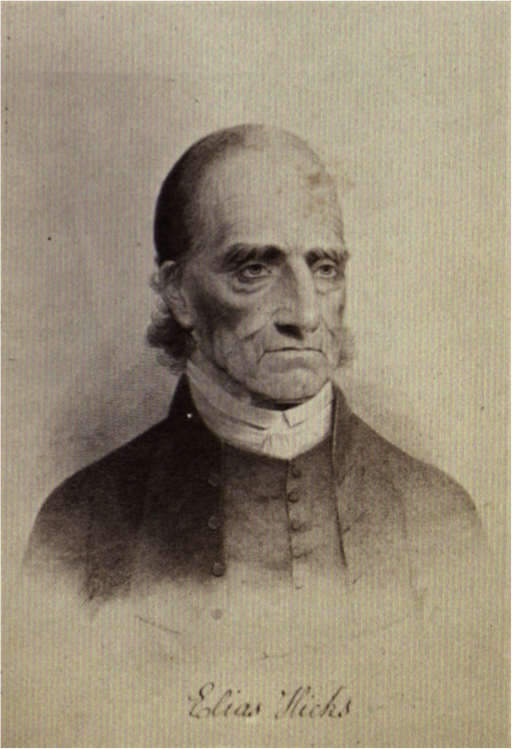
Figure 12: Quaker minister Elias Hicks
The wounding and the rhetoric come to life in the private papers of the Hicksite Painters and the Orthodox Emlens. As a memorial to the rupture, the Painters kept copies of the written disownments that each adult member of their family received from the Orthodox in 1828: Enos for having been an active promoter of separation, Hannah and the younger generation for having “associated with others in holding meetings contrary to Discipline and Subversive of the good order & harmony of our Religious Society.” Hannah grieved, since her closest friends in the society were on the other side. Enos turned the tables when James Emlen challenged him about his beliefs, and Minshall recorded the conversation. Was the grace of God, Enos asked, not “sufficient for salvation” even without the Bible, and did James consider its every word inspired? James replied that civilization did need the Bible to stay on God’s path, and its meaning was “all clear to him.”
Minshall challenged the whole Middletown community on behalf of the Hicksites, joining a fellow member through these same months in compiling not only an official list of those on each side, but each person’s reasons. Every adult man and woman was asked for a commitment, and children signed by parental consent. Thomas Pratt was declared a Hicksite at eleven by his mother and guardians, but Humphrey Yearsley’s guardian spoke over the head of mother Tacy, declaring that “she had her notions and is not fit at all times to judge for her self.” In fact the Yearsleys chose against the guardian, remaining Orthodox. Minshall’s procedure was confrontational, especially to people who did not fully understand the controversy, but to his credit he stayed to hear and record their questions and states of doubt. One man engaged in “considerable conversation” and then refused to sign either way. An aged and infirm woman kept repeating simply that she was a Friend. Since both sides were claiming that name and labeling the other differently, this response clarified nothing, but her state of confusion is understandable. Though the Emlens signed the Orthodox list, they offered no reasons, either because they refused Minshall’s inquiries or because their position was patently clear.
Sarah and James had a great deal to say, however, and a small part of their expression of Orthodoxy survives in letters and memorials. Even after leading the monthly meeting to their house in the spring of 1828, for five months the Emlens and their local group continued weekly worship along with the Hicksites at Middletown meeting. Apparently there was just too little space for them at any private house. We hear of this difficult time because James had gone on a long journey to Ohio and North Carolina representing the larger Orthodox sect, and Sarah wrote confiding letters from home. In characteristically Biblical language, she urged him not to fear to “face the Great Goliath of our Israel,” but to go forth like David “with the sling, & smooth stones from the pure stream.” She did not back away from conflict. But the ways she experienced conflict herself were so direct and hostile that by August of 1828 she felt “pressed down to the very earth.” As she told James, on the handrail in front of her seat in the meetinghouse she had found a message in pencil addressed to Sarah Emlen by name and condemning “you poor misguided friends/ To whom the Devil his angel sends.” “What my dear dost thou think they aim so at me for, what have I done to merit so much of their hatred [?]” Less than a week later the Hicksites walked out of meeting in protest, and at its end she found another penciled message, this time written on the wall behind her in large letters by a person who had apparently reached down from a window above: “Celebration of the Hicksits day and downfall of the Orthdx—liberty by the point of the Sword—Orthdx women were d mn bitchs --&c. &c. &c.” Such a shocking violation of Quaker charity could be recorded only in private.
Sarah’s letter also went on, however, to say that soon their enlarged schoolhouse would be ready for meetings, and by October she could hear the noise of workmen as she wrote. Minshall Painter recorded the actual change from the Hicksite point of view on November 2: “We met today by ourselves, the Orthodox do not now meet with us….I hope they may ever continue away unless they will meet us better conditioned.” For seven years thereafter, the Orthodox met in the Emlens’ school by Yearsley Mill, until they could build the meetinghouse on Middletown Road that survives today. Both Emlens continued to speak out as Orthodox leaders even after they moved to Westtown School in 1835. The poem that James inscribed in a student’s album offered a more eloquent answer to the question Enos Painter had once posed: “A man of subtle learning asked/ A peasant if he knew/ Where was the internal evidence/ That proved his Bible true./ The words of skill and studied art / Had never reached his ear/ He laid his hand upon his heart,/ And only answered here.” Sarah continued as a traveling minister of considerable stature, inscribing long journals of her experiences as far away as Ireland and London. Decades later the Orthodox still remembered her as “our late Friend.” James retired to West Chester after Sarah’s death and wrote copious letters of spiritual advice, eight pages of which are quoted in his memorial.
After the Quaker Separation, Minshall Painter turned largely to science and civic improvement, and he has even been characterized by one eminent scholar as a deist and infidel with “no use for religion.” But an important, never previously cited essay, written in October 1828 just as the Orthodox were finally leaving the meetinghouse, shows how deeply rooted he was in Quaker principles. In “Reflections and observations on the subject of Friends treating with Orthodox Elders,” he tried to recall the Hicksites to the unity and “discipline” that they had long shared with all Friends. There had been a procedure for dealing with difference, and what happened instead was “highly culpable and very indecorous.” He did feel that the other side’s disownments had begun the decline, but the Hicksites should not have responded with the same anger. Minshall spoke eloquently from his knowledge as a scientist: “Must we become as highly charged as they are like two electric balls that are highly charged with the same kind of electricity [?] Or like the same pole of two magnetic needles before we can possibly repel each other to a sufficient distance [?]” He also invoked the American Constitution, which had created a nation out of disparate states and people. In his view Quaker union had been a forerunner of it, and “the disturbances that have and are now taking place are a reflection on the American character.” Even now he proposed negotiation and reunion. Or else “we can let those who differ from us depart without casting a censure or a frown after them but bid them go in peace.” As his diary revealed on the day the Orthodox actually departed, even he felt emotions to the contrary. Still he was expressing profoundly the Quaker principle that both sides shared.

Women
Every aspect of this study has included women, but they also deserve focused attention as a sample of half the American population that, in course of the nineteenth century, underwent fundamental changes of status. What kinds of change can be seen in the surviving record of the Pratt, Emlen, Yearsley, and Painter women? Though many women’s historians of recent decades offer helpful perspectives on the question, Joan M. Jensen has in particular offered guidance to multiple classes taught by George Franz and Phyllis Cole at Penn State Brandywine. As Jensen proposes in her study of Chester and Delaware County farm women, there was no revolution, but they still underwent a decisive “loosening [of] the bonds” of womanhood.
The bonds in question were legal, political, and religious. According to the English Common Law, which was also practiced in the early United States, a married woman was a “feme covert,” “covered” by the identity of her husband and therefore ineligible to own property, keep her own wages and profits, or conduct a lawsuit. In keeping with this law, she was also a non-citizen of the nation and could not vote. And—the oldest prohibition of all—she could not preach or minister: as St. Paul had decreed and mainstream Christianity maintained, “the women should keep silence in the churches” (I Cor. 14: 34). Our group of women, as members of the Society of Friends, had already countered that Biblical rule and, following the example of their ancestors back to the seventeenth century, felt free to speak and to organize their own, self-governing women’s meetings. But as the daughters and wives of land-owning men they fell entirely within the property law, and as residents of the United States they were excluded from the rights of citizenship. The bonds loosened when they claimed new access to land and money, when they pursued education, and when they moved toward citizenship with public roles, in and out of their own Society.
Property law. Recall the unhappy domestic argument between Thomas and Mary Worrall Pratt over her right to the land and capital she had inherited from her parents. Thomas was expecting the old ways to continue. His own father, his guardian Enos Painter, and the founder of the Darlington dynasty had all come into their land through marriage to a daughter or widow from another family, and apparently no one complained: a wife’s estate simply belonged to her husband. But the law and social climate were also shifting. The decisive change came in 1848, when Pennsylvania enacted a Married Women’s Property Act, allowing women both to retain the property they brought into marriage and to acquire more in their own name. And even before that time, a growing alternative to common law called “equity” allowed the courts to put a woman’s inheritance into a “trust” that would protect her right to it from an actual or potential husband’s decisions and debts.
Such arrangements were clearly in play with the Worrall family, from whom Mary received her inheritance. When she reached adulthood in 1838 she inherited land—the property later developed into Cumberland Cemetery—from her father, who had died seven years before but willed it to be held in trust for her. After the death of Mary’s mother in 1858, Thomas promised her brother Sharpless to have the money that Mary also inherited “properly secured for her,” but that meant controlling it himself, even losing it to unsuccessful land speculations in Minnesota. For a long time after the Property Act of 1848, household hierarchy could make de facto coverture continue.
Ironically, Thomas Pratt meanwhile signed as an official witness to the will of his childhood guardian Enos Painter, who in 1848 followed the liberal trend in apportioning his substantial estate. Though his sons Minshall and Jacob were to inherit the land in Middletown, Enos went to great lengths to protect the rents and profits that his daughter Sarah would receive on Chester County property from husband Eusebius Barnard; they would be “for her sole and separate use,” “notwithstanding any coverture.” These were the key phrases of equity law, and even though the Property Act had just claimed such privileges for all Pennsylvania women, Enos doubled the prohibition against this husband’s possible expectations of profit. Possibly his distrust of Eusebius actively motivated such provisions as much as confidence in a daughter’s ability. But this lengthy will also opens possibilities of ownership and economic security for other sisters, daughters, and granddaughters. The Painter family—even its tough-minded patriarch—seems to have been united in respect for women’s economic rights.
Ann Painter Tyler (1818-1914), the youngest child of Enos and Hannah, acted out such possibilities most fully. Married to William Tyler in 1847, she benefited directly from her brother Minshall’s will, which in 1873 left her the family home, farm buildings, sawmill, and tenant houses. There was no question of her husband William becoming the real owner; the 1875 Middletown map labels this property clearly with her name alone. Even more, the family’s legal papers include nine leases by which she rented out the tenant portions of her property over the years following. Samuel Byers, for instance, was mandated to “improve” the farm he rented, keep it free of “all pernicious weeds, briars and bushes,” “protect the fruit and ornamental trees,” “keep eighteen cows and four horses, but no more,” and “keep the hogs from rooting”; at the mill, Davis Williams was to “saw lumber for her” while she reserved “the privilege of entering on the above premises” to inspect and supervise repairs as needed. The legal language put this woman (now in her fifties) in charge down to the details, and it was not until 1882 that the name of her son John J. Tyler appears as agent for her. It was through the lineage from Ann to John J. to John’s widow Laura Hoopes Tyler that the place evolved into Tyler Arboretum.
The Painters were among the wealthiest and most eminent families in Middletown, but they were not alone in moving toward women’s agency with land and money. Mary Worrall Pratt may have died without reaching any resolution with Thomas, and Catherine Yearsley went from a “trust” that gave her no power to impoverishment by her husband’s debts. But the same 1875 map that shows Mary’s estate at the Cumberland site and Ann Tyler’s single ownership also reveals a bigger picture: just twenty- seven years after the Married Women’s Property Act, more than ten per cent of the hundred-odd landowners in Middletown were women.
Education. The same woman who owned and managed the Painter properties in the 1870s also learned chemistry in the 1830s. In fact we can know a great deal about the education of Ann Painter Tyler, because the family archives include her school notebooks, from arithmetic at Westtown when she was ten to a range of subjects at the West Chester Female Boarding School in her teens: French grammar, geology, the numbers in Latin and Greek, a book of extracts from poetry, and in all of them samples of exquisite penmanship. As her chemistry teacher acknowledged, “our female seminaries” were a growing concern.
Education took many forms in Pennsylvania’s Quaker culture, extending for the community of our study from the school alongside the meetinghouse to public elementary schools for the county, from Westtown in 1799 to the seminaries and colleges of later decades. Women’s literacy and opportunity within this system was relatively strong. But the Painters offer a special case to examine by virtue of both their means and their motivation.
Not only schoolbooks but letters tell of the struggles and triumphs of girls away from home over three generations at seminaries and colleges with financial and personal backing from the Painter elders. The first Painter to attend Westtown Boarding School was Rachel, the illegitimate daughter of Enos’ sister, who subsequently wrote to Hannah about her teaching career in Alexandria, Virginia. Hannah’s four daughters (Sarah, Hannah, Sidney, and Ann) followed at Westtown, with cousin Rachel encouraging Sarah to enjoy the same opportunities she had had. In turn Ann kept the tradition going for the generations after her own, perhaps in special ways since her older sisters had died and their daughters and granddaughters needed mentoring. A niece, Sidney Barnard, wrote with pride in 1887 about her daughter Helen’s enrollment at Swarthmore College; later, after graduation, the daughter celebrated annually with “old Swarthmore girls” while planning a nursing career, which in the mother’s eyes promised both satisfaction and economic return. Helen herself expressed more self-doubt to Ann, complained of exams ahead, invited her to commencement, and offered thanks for “what thee has done for me.” “I think I can be a nurse but I do not know about being a doctor,” she wrote from her training school. “Time will show.” Surveying the college ventures of not only Helen but her cousins in 1887, Sidney summed up the new promise of their time: “Tis education forms the common mind.”
The great-grandmother of such formation, however, was Hannah Minshall Painter, who had received a “liberal education” such as the 1790s offered before her marriage to Enos. The records do not tell where she attended school or what subjects she studied; there is certainly no suggestion of science or languages. But her large “Copy Book”—also in exquisite penmanship—tells of the thoughts and values that she was being taught. Also called “commonplace books,” such albums are studied today as a clue to women’s culture of the past and a kind of autobiographical expression, because the students chose for themselves (probably from shared or recommended reading) the passages of poetry and other literature they wished to include. Hannah had a sense of humor, as her “Advice to Choose a Husband” and “Last Will and Testament of Father Amity” show: the latter is a parody version of what a husband might leave a wife from the household goods that had been legally his (“A Tub of Soap/A Long Cart Rope/A Frying Pan and Kettle,” etc.) The era’s moral warning to girls is expressed in “The Heavenly Damsel,” which recounts the judgment visited upon a young woman guilty of infanticide; angels tell her she will be forgiven if she returns to let the world know what she has seen. Specifically Quaker values and vision also loom large in this selection: a prospect of the Quaker millennium of peace, the evocation of “inward light” possible to a bedridden young woman, and an elegy to the woman minister from nearly Goshen, Elizabeth Ashbridge, who left her husband and sacrificed her life to travel abroad with religious testimony. The selections in Hannah’s book confirmed the domestic and religious values that she had grown up with but also allowed her to see them more deeply. Joan Jensen quotes Hannah’s transcription of the poem about Elizabeth Ashbridge in pointing out that women ministers were important “models of emulation” for other young women. Emulation would continue through the century following, both within the family and through the models that schools and books offered from outside it.
Professions and public authority. The major routes toward public citizenship for women in Quaker Pennsylvania were teaching, ministry, and reform, all of them positions that the young might emulate. Hannah Minshall herself never took on such work, but she also knew a woman—Sarah Emlen, just five years younger than herself—who had embraced both teaching and ministry. As Middletown neighbors and fellow leaders of the women’s meeting before 1827, they must have known each other well; maybe Sarah was one of the “intimate fellow members” whose loss through the Separation most grieved Hannah. In any case the two women’s records of education and piety make an interesting pair. If Hannah is a foremother of education, Sarah represents public vocation. Instead of a commonplace book, Sarah offers an extraordinary body of life writing, which does not detail her means to ministry but does express the interior experience driving it. Sarah started keeping journals at twenty, in 1807, and at least sporadically through more than thirty years continued to record her travels and daily reflections in journals and letters. Her account of opposition at the Middletown meeting in 1828 was only an episode in a much more extensive life narrative, which sought to embrace both the domestic sphere of the family and the daunting requirements of a travelling ministry.
Loneliness made Sarah want to record her thoughts, and necessity made her daring. Born in rural New Jersey, she had lost her mother and father early, though early advice from her father (a teacher) to compose a journal provided Sarah with “social chat” when other company was lacking. Her other most prized setting for conversation was Westtown School, where a band of friends and a set of teachers attuned to her confidences provided new grounding in life. She herself started teaching when only sixteen. But she told such background retrospectively in the midst of a contemporary account from the Ohio River Valley, where she married, then lost both husband and child to epidemic disease. Her intense religious vocation seems to have taken root in feelings that she had loved them too much, “better than the giver,” and now “must seek something that will never die.” Travelling back across Pennsylvania with strangers, she returned to Westtown as both a haven and a place of employment as a teacher. Then the journal record falls silent for three crucial years, during which she met and married James Emlen, became a mother again, and simultaneously began to travel as a minister. New love and religious vocation had come to her at once, and for the rest of her life she would (like many other Quaker women ministers) struggle to fulfill both callings.
Sarah’s certificate from Chester Monthly Meeting in 1825 declared her a “minister in good esteem with us” and recommended her “visit in Gospel love” to the meetings of New York and Rhode Island. A minister was not ordained or specially trained, but meetings had long recognized the few among them with a special gift for speaking and conferred this status as a recommendation, even to meetings far from their own. By 1828 there were ninety women ministers in greater Philadelphia, still an elite group but one growing in size and stature. It was surely against such stature that the Middletown Hicksites were recoiling in their profane and misogynistic slurs against Sarah that very year. But the journals themselves express the difficulty of having authority and remaining humble at once. Finding herself embroiled in a pre-Separation controversy in Saratoga, New York in 1825, she prayed to “keep down that spirit which would feed on these things,” to “keep innocent, not craving the fruit of the tree of knowledge of good and evil.” Clearly one side of herself did want authority and knowledge. At least in her journal she did not hesitate to criticize people “so wrestless, and so outward,” whose hearts did not seem attuned to her words. She could judge and discriminate. Finally, and despite a constant theme of homesickness and love in the letters, Sarah also found valued associates in these travels. The last surviving letter before her death in 1849 was to a “sister in truth” in Liverpool, England, with whom she proposed simultaneous reading and reflection on Moses’ prayer to God as he led the Hebrew people. She had no qualms about making an analogy between this august figure and themselves.
Women’s ministry in the Society of Friends was not a new development in the nineteenth century, like property rights and higher education, but surely it gained new meaning in changing times. From her New York experiences on, Sarah had a part to play in the Quaker controversies. She was welcomed in regions far afield from Pennsylvania. She also remained close to school-teaching, at home and at Westtown, even while ceding the latter position primarily to James. In Jensen’s terms she stands as an emerging public citizen of the era, alongside Rachel Painter, who taught in the unfamiliar territory of the South, and later Helen Barnard with her aspiration to a medical career.
It is not clear from our limited research that new institutions in Delaware County opened doors very wide to women. In this neighborhood the leaders in temperance and antislavery reform, at least as reported by newspapers and official histories, were men. The Delaware County Institute of Science allowed a few women to become “Associate” or “Corresponding” Members, like the eminent Quaker minister from Philadelphia, Lucretia Mott. But why was there not space alongside her brothers for Ann Painter Tyler, with her passion for chemistry? Instead the Institute had a “Ladies Fair” in 1868 with Mrs. Tyler and Mrs. Yearsley on its large planning committee. Even in a changing time and place, most women remained beneath the radar of public recognition. Why was there no eulogy of Sarah Emlen in The Friend, as there were of the two James Emlens?
Still, under the leadership of Lucretia Mott, this region hosted one of the early women’s right conventions, in West Chester in 1853. Jacob Painter rather than his sisters was consulted by the radical Hicksite women planning the event. More power to him for responding; on his own initiative he had also attended the first convention in Massachusetts. At some point he wrote an essay on women. “With what derision men speak of a woman who assumes to have any mind,” Jacob commented; “how they ridicule their pretensions as presumptive[,] but…their scoffing denotes their little childish je[a]lousy.” We do not at this point know to what extent the women of Middletown attended or responded to the meeting in West Chester. One sign of long-term interest, however, is a much later report from another of Ann Painter Tyler’s nieces, Anna Sharpless, who in 1888 attended a Woman’s Council meeting in Washington, DC. Telling of the opportunity to hear “the finest women speakers we have in the United States and some others belonging to foreign lands,” she also sent her aunt a copy of the Woman’s Tribune with full coverage. This representative of the next generation assumed Ann’s support of her presence there and of women’s cause.

Cumberland Cemetery
Fittingly, the story ends in Cumberland Cemetery, the final resting place for many Pratts, Painters, Tylers, Worralls, and Darlingtons, where individual women and men were (more than in life) equally recognized, their families around them, their gravestones affirming eternal life. Minshall Painter recorded in 1859 that Thomas Pratt was “laying out a piece of ground for a cemetery” alongside the Friends’ graveyard, and by the end of 1860 the Delaware County American acknowledged its operation with the notice of Elizabeth Sill’s funeral procession from Edgmont “to Cumberland Cemetery, Middletown.” The name “Cumberland,” as a map of original land grants from William Penn shows, had been associated with this property since the seventeenth century. Claiming it through his wife Mary’s inheritance, however, Thomas Pratt used the name of a county in northern England for a new purpose. This was not a Friends’ burial ground, nor attached to any other church affiliation or township. It was a place of rural peace, without denominational ties and open to any who cared to buy into it.
Buying remained an important aspect of the arrangement. By no means an enclave only of the wealthy, it was also not for the poor or the anonymous stranger. Nor do we have any evidence that the blacks in Lima or the mill workers of Rockdale were represented at Cumberland. The Honeycomb United African American Church on Barren Road and the evangelical churches of the lower Chester Creek served those communities in life and death. Cumberland was primarily for the white Protestant middle class residents of the region.
The cemetery has proven a good neighbor to students from Penn State Brandywine. Graveyard studies are a thriving branch of interdisciplinary American Studies, embracing art, archaeology, religion, and social history; students of Phyllis Cole and Laura Guertin have looked with care at its tombstone weathering rates, its representations of gender and social status, and its changes from the mid-nineteenth century through the twentieth. Nor does the place stand alone: the lives memorialized in it extend outward to Minshall Painter’s journalizing about them, to an official “Interment Journal” that lists home towns and causes of death for those buried from 1885 on, and to the newspapers and public records that tell more of individuals named on these stones. As Eileen Fresta writes in her senior honors thesis, work developed through both Cole and Guertin, Cumberland Cemetery is “alive with history,” itself a historic landmark and a key to the society and culture beyond it.
In particular, Cumberland is in its origins a modest contribution to the “rural cemetery” movement of nineteenth-century America. Like its much larger predecessor in Philadelphia, Laurel Hill, Cumberland was open to “lay expressions of the meaning of death” because of its separation from particular churches. Look over the stone wall dividing it from the original Quaker burial ground to see the difference. From the early eighteenth century, approximately 1200 people had been interred by the Quakers in very small space and in the order of their deaths; a written record was kept, but grave markers were considered worldly ostentation, and only in the nineteenth century would even the smallest stone markers with names and life dates be allowed to remember the dead. The Painter brothers’ regret that their mother had no memorial but the magnolia tree they planted is one sign of discontent with such communal and self-effacing customs. On the other side of the wall Minshall and Jacob purchased lots for their own elaborate mausoleums, which declared to the world who they were and what they had stood for, amidst carved emblems of the nature they revered. All around them in this oldest (northern) part of Cumberland are more modest grave-markers, including Thomas and Mary Worrall Pratt’s, often with Quaker dating (“tenth month” instead of October) that reveals their origins. But even these are larger and taller than the humble markers next door, and some stones even combine Quaker dating with decorative Victorian carving. Choice was actively encouraged, individuality and family affiliation affirmed. Graves were set in a garden-like space, so that family members might visit and pay their respects to the dead. A direct descendant of Thomas and Mary Pratt, Betty Ann Hadley, reports that in childhood she would join her relatives in visiting Cumberland to care for the family graves, and she enjoyed running around on its “spit-spat” grass and gravel pathways. Rural cemeteries were for the living as well as the dead.
Walking among the gravestones of Cumberland allows visitors even now to survey the choices that surviving family members once made. In the oldest part of the cemetery, open areas suggest that not all grave sites were marked in any way; a ground-penetrating radar study shows more than a hundred unmarked burials, at least some of them influenced by the old Quaker custom. On the other hand, the status and wealth of individual families are openly declared through fenced enclosures, imposing obelisks, and mausoleums like the Painters’; at the southern end of the cemetery, their nephew John J. Tyler is memorialized in one even more imposing, if less ornate. Gravestone art and poetry openly lament the deceased and declare them partakers of heavenly immortality; Victorian optimism and sentiment prevail over older cemetery images of death and divine judgment. Among the symbols carved in rock at Cumberland are a willow tree for mourning; a broken chain, plucked rose, and hourglass for mortality; an upward-pointing hand, lily, or evergreen bough for the heavenly afterlife; and crosses for mainstream (non-Quaker) Christian church members. Words add to visual emblems, whether original or provided by the hired gravestone artist. “No night in heaven,” one epitaph simply declares in 1888. A year earlier, another addresses a more poignant message to the deceased woman of thirty five: “Thy hands are clasped upon thy breast/ We have kissed thy lovely brow/ And in our aching hearts we know/ We have no mother now.”
Cumberland served Quakers, ex-Quakers, members of other denominations, and non-believers like. The same might be said of other Philadelphia-area cemeteries—like Laurel Hill, whose guidebook declared it a place where “all parties can meet in forgiveness and harmony.” But Cumberland is especially evocative of harmony in extending literally from the property of the Hicksite meetinghouse to the property of the Orthodox meetinghouse. We do not know how many Orthodox actually chose Cumberland; eventually they had their own burial ground too. But in design it provides a bridge or at least a buffer zone between the separated Quaker communities. Thomas Pratt offered no statement of intent, but let the landscape speak for itself.
After Pratt’s death, Cumberland also became an incorporated business of more explicit design and outreach to the public. The origins of this shift lay in his own contested ownership of the land—a conflict about which there had apparently never been any resolution or forgiveness. When he willed all his land holdings to his second wife, Sarah Johnson Pratt, the children of his first marriage sued to regain their mother’s land and capital. Though they won much of it back, Sarah retained the cemetery land, which she then sold by auction to pay other debts of the estate. As the Chester Times put it, a “syndicate of gentlemen” bought these seventy acres in 1885, and soon they were advertising “A New Place of Burial” called Cumberland Cemetery. One of the gentlemen, James Smith, became its superintendent, living for more than twenty years in the new Gothic-style cottage by its gated entrance. As incorporated by this group and carried out by Smith, the cemetery now required a detailed “interment journal” keeping track of burials and causes of death, and the cemetery itself adhered substantially to a more geometric plan known as “Lawn Park” style. The individualistic gravestone art of the rural cemetery was regulated, and perpetual care made family maintenance of graves unnecessary. Or at least that was the apparent intention. In fact Eileen Fresta concludes that Cumberland in the later nineteenth century was a “crossroads” of rural and Lawn Park style, with large monuments and gated plots still permitted. Both the inscriptions quoted above (from the 1880s) and the Pratts’ reported custom of maintaining their own family plots (well into the twentieth century) were part of the older way.
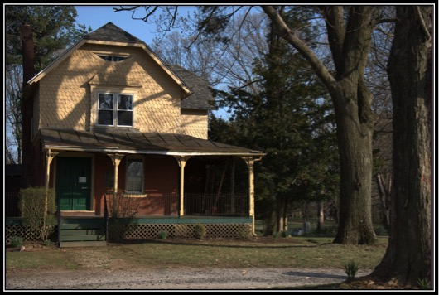
Figure 13: Cumberland Cemetery superintendent's cottage
Cumberland Cemetery, especially in the context of its lists and documents, is a rich resource for understanding this region, offering both an aggregate of human information and a key to individual lives. The Interment Journal lists 2261 burials from the 1890s through 1980s, and the gravestones add many hundreds of earlier burials to the total. In the 1930s the Works Progress Administration listed all the readable grave sites by name and number, providing a baseline for comparison with what we can see now. And these thousands of human cases connect with records contemporary to their own lifetimes. Minshall Painter proved true to his indefatigable habit of record-keeping with a journal called “Necrology,” commenting on particular deaths in his time and place. The county’s archive of wills and property records, as well as searchable websites, offer access to family records and contemporary newspapers. Here we can sample only a few of the conclusions that American Studies students at Brandywine have reached in their scrutiny of these materials.
Those buried at Cumberland are not just from the Middletown neighborhood, but from an area extending throughout the region, from Chester to Philadelphia to Kennett Square. As Eileen Fresta discovered under the guidance of Dr. Laura Guertin, over the decades covered by the Interment Journal average life expectancy rose from 40.55 years in the 1890s to 75.9 years in the 1980s, numbers corresponding roughly to those of the US Census Bureau and skewed by the larger number of childhood deaths in early years. A charting of causes of death reflects the near-disappearance of tuberculosis and diphtheria over these decades and rising rates of cancer and heart disease. The use of gendered family titles was the focus of research by a group of Guertin’s students: surveying 269 gravestones of men and 229 of women, they discovered that while only 18% designate the male deceased as “Husband,” 49% designate females as“Wife”; on the other hand, 47% of the men are called “Father” and only 37% of the women “Mother.” The marital bond is apparently considered the dominant identification of a woman, whereas parenthood stood first for men.
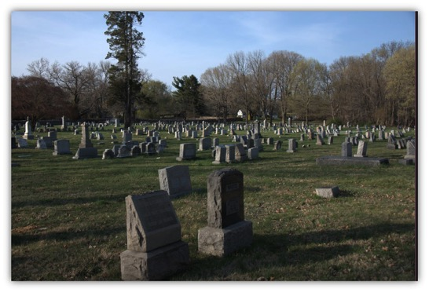
Figure 14: Cumberland Cemetery
American war service is reflected throughout the cemetery’s existence: records at the Delaware County Archive confirm the graves of 106 Civil War veterans buried at Cumberland, along with veterans of the Spanish American War, World War I, World War II, and the Vietnam War. The graves of many Civil War soldiers are marked “GAR,” noting their part in the “Grand Army of the Republic.” Among them we have also glimpsed individual characters. Minshall Painter’s “Necrology” tells of Richard Passmore, who died in 1863 after being “taken prisoner by the Rebels and taken to Richmond…where it is represented he was severely used,” dying from abuse and starvation despite a prisoner exchange. Others returned home and had long post-war lives, three of which were researched as case studies by individuals in Cole’s 2003 American Studies 491W class. Having been wounded at Fredericksburg, Joshua Pusey came home to invent paper matches and numerous other ingenious devices, commuting into Philadelphia from his estate on Middletown Road; Joseph Pratt served as captain of the 124th Pennsylvania Infantry, then became a merchant with sufficient resources to leave numerous clocks and gold watches to his children; Charles D. Manley Broomhall grew up in Edgmont, served directly under Joseph Pratt, and returned to become a lawyer and district attorney in Media. In recent years his detailed diary of the battle of Antietam has resurfaced in Connecticut and been published on the internet.
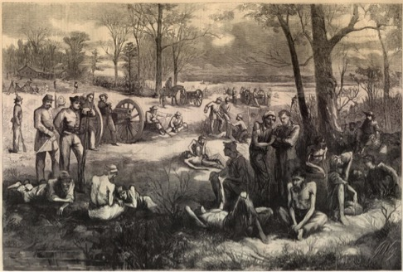
Figure 15: Civil War prison camp
The women are, of course, much harder than male soldiers to trace from their gravestones to the public record. Sarah Danfield was the wife of Samuel, a Chester grocery store owner and city councilman, each of them represented by a marble stone of equal size, side by side. But Samuel’s 1888 will, while careful in its provision for his “dear wife Sarah,” also speaks for her by saying what he bequeaths to others after her death, an event still nineteen years in the future at the time of his decease; such instruction certainly exemplifies women’s traditional deprivation of voice and will, as opposed to the spiritual equality that the gravestones represent. On the other hand, Sarah Griswold not only crafted a remarkably detailed will before her death in 1874, parceling out household goods among her three children; she also preserved her dowry in the form of “principle of a bond” for $3000 which she held apart from her husband Job, specifying that it should be divided equally among the children when he died. Not co-owner of their 141-acre farm along Chester Creek in Middletown, she was still an agent in family finances.
But we must conclude with the Pratts and their kin, owners of the Cumberland property and our central cast of characters in this study. Minshall Painter’s “Necrology” offers a valuable report on two of them, both buried in the cemetery. Thomas and Mary Pratt had four sons but left land to only three: what had become of the fourth? Painter’s vignette tells of the risks to life on their apparently bucolic farm: in 1872 Phineas Pratt “came to his death by the bursting of a fly wheel…while at work cutting hay being struck by a piece of flying timber…He was a very ingenious and intelligent young man and he died much lamented.” A more positive ending is given to his mother Mary, whose inability to participate in management of her inheritance had been so keenly felt. Two years before Phineas, Mary Worrall Pratt died “much respected,” and “the funeral was attended by an unusual number of people.” The community if not the execution of law could give this woman recognition.
All the Pratt children are buried at Cumberland, within sight of the farmhouse where they grew up. The cemetery offered an inclusive landscape despite the contentions around it. In fact the inclusion extends beyond Thomas and Mary’s immediate family circle, as two additional student case studies from 2003 have led us to realize. Sharpless Worrall, the brother who testified about Mary’s exclusion from her inheritance of the cemetery land, is also buried there along with his wife; as he approached death in 1887, this Willistown farmer overcome any lingering resentments and invested in Cumberland. And so did Joseph Pratt, the Civil War captain. Though in 2003 it was unclear how he was related to Thomas, our dairy farmer and cemetery founder, further genealogical digging has revealed him to be a second cousin, directly descended from the eldest Pratt who had once inherited the land that is today Colonial Pennsylvania Plantation. But Joseph’s descent was illegitimate: his grandfather had been the product of that eldest brother’s youthful misdeeds, and there was no prospect of land inheritance for him or his descendants. Instead grandson Joseph (1834-1908) grew up in Gradyville, became a grocer, and did well in both commerce and military service. His fenced family plot and “GAR” emblem at Cumberland—all considerably more prominent than the Quaker-plain gravestones of Thomas and Mary Pratt—are a deserved declaration of pride, status, and family membership.
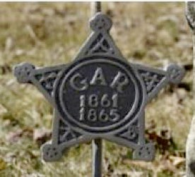
Figure 16: Grand Army of the Republic grave marker

Notes Underground Railroad activism in Middletown was centered primarily at Honeycomb U.A.M.E. Church on Barren Road, supported by the community of free blacks who founded it, with support from white, mostly Quaker activists in the area. None of the principals in our story were direct agents. Likewise none owned or operated the cotton mills springing up along Chester Creek and described by Anthony F. C. Wallace as “enterprising men.” Nonetheless these nearby scenes help define the neighborhood, and Larry Smythe, Jr. adopted Wallace’s phrase to identify Thomas Pratt’s farming capitalism as well as the mill owners’. See Mary Ann Eves, Middletown Township, Delaware County (Charleston, S. C.: Arcadia, 2011), 90-91 on Honeycomb Church; Wallace, Rockdale: The Growth of an American Village in the Early Industrial Revolution (New York: W. W. Norton, 1972), 406 on the cotton mills; Larry Smythe, Jr., “Thomas Pratt: An ‘Enterprising Man’ of Nineteenth-Century Delaware County, Pennsylvania” (Schreyer Honors College thesis 2002), 1-2.
Penn State Brandywine student Breath-Alicen Hand measured and estimated the age of the sycamore, following her work on the project “Penn State Brandywine Tree Removal Eco-Services Impact Survey” (2016), with professors Laura Guertin and Joshua Marquit. Thanks to all of them as well as to biology professor Mark Boudreau for suggesting this measurement. Hand also found twenty-three black cherry trees in the immediate vicinity of the Pratt farmhouse. This discovery corresponds to John Vairo’s memory of fruit trees as well as lilacs on first seeing the house site, as recounted to Phyllis Cole and Laura Guertin in 2003 when we walked the campus land together.
Schreyer Honors theses: Smythe, “Thomas Pratt” (2002, winner of Delaware County Annual Preservation Award Certificate 2003); Eileen M. Fresta, “A Study of the Cumberland Cemetery in Middletown Township, Pennsylvania” (2013); both theses are available through Penn State Libraries and deposited at the Brandywine library. Independent Studies Projects: Gloria Boyd, “The Pratts, Painters, and Darlingtons: Three Generations of Change” (2004); Virginia Livanos, “The Social Context of Nineteenth-Century Women” (2014); Kevin Pistiner, “James Emlen’s Expedition to the Native American Treaty,” “Sarah Emlen’s Poetic Letters,” and “Operation of a Grist Mill” (2014). Internships: Eileen M. Fresta at Cumberland Cemetery (2012), Shannon Crowe, Youth Education Intern at Tyler Arboretum (2014). Beyond undergraduate work, Kevin Pistiner wrote his MA thesis in American Studies at Penn State Harrisburg on this local case study: “The Great Schism: A Divide among Quakers and its Impact on the Middletown Friends Preparative Meeting in Pennsylvania” (2017). Shorter projects from Cole’s “American Lives” (AMST 491W) classes, as well as projects by Guertin’s students, are cited in other notes, but a special acknowledgement is due to the Fall 2003 classes of both: Cole’s students researched information on individuals interred at Cumberland, and Guertin’s studied tombstone weathering rates; both presented to campus guests on Penn State Day under the title “Tombstones and Spirits” and were co-winners of a Delaware County Annual Preservation Certificate in 2004. Since returning to teach on campus, Smythe has always introduced his American Studies and History of Pennsylvania students—including Fresta and Pistiner—to this historic landscape.
Smythe, 20-22.
As children (1828) both Thomas Pratt and Mary Worrall were listed along with their elders as members of meeting. But the Worralls apparently opted out, because on May 21, 1840 the Orthodox meeting questioned Thomas’s marriage to “a woman not in membership with friends by the assistance of a magistrate.” In 1883, after Thomas’s death, Hicksite records still listed him as a member, but not Mary. Membership 1827-64, Chester Monthly Meeting Records [Hicksite], Swarthmore Friends Historical Library; Minutes 1821-47, Middletown Preparative Meeting [Orthodox], Haverford Quaker and Special Collections.
Smythe, 6-9, citing Tobi Graham, Pratt Family Tree and Genealogy, 1600-1871 (1999 typescript provided by Colonial Pennsylvania Plantation), 1-4. The family history of Thomas’s older brother Joseph is detailed in Graham, 5-9.
Smythe, 8-9, 12, citing Graham, Pratt Family Tree (“1999 Update”) on Thomas Pratt (1764-1820) and his second marriage.
Smythe, 12-14, citing “Enos Painter Guardian of Thomas Pratt,” Series 4, Box 27, Painter Family Papers, SFHL.
Membership 1827-64, Chester Monthly Meeting Records, SFHL; Minutes 1821-1847, Middletown Preparative Meeting Records, HQ&SC. For the history of Westtown School, a resource for so many Middletown Quakers, see Watson W. and Sarah B. Dewees, History of Westtown Boarding School: 1799-1899 (Philadelphia: Sherman, 1899) and Helen G. Hole, Westtown through the Years, 1799-1942 (Westtown: Westtown Alumni Association, 1942).
Smythe, 22; on women’s crucial role in Pennsylvania dairy farming, Joan M. Jensen, Loosening the Bonds: Mid-Atlantic Farm Women, 1750-1850 (New Haven: Yale University Press, 1986), especially chs. 5 and 6.
Jensen, 94. Gloria Boyd, in “The Pratts, Painters, and Darlingtons: Three Generations of Change” (2004), interviewed descendant Jared Darlington about this business and its wide market, dependent on the train stopping directly at their property in Middletown. A direct sign of their prosperity was the quadrupling of their original farmhouse into an Italianate Victorian; likewise the Pratts and Painters either remodeled their pre-Revolutionary houses into country mansions or built anew.
Smythe, 35-36, quoting Ashmead, History of Delaware County, Pennsylvania (Philadelphia: L. H. Everts & Co., 1884), 633, and citing Jane Levis Carter, Edgmont: The Story of a Township (Kennett Square, PA: KNA Press, 1976), 41.
Smythe, 37, quoting the Delaware County American, May 9, 1860 (Accessible Archives).
Smythe, 23, 26, 28-29, citing Ashmead, 590, 632-33.
Smythe, 38, 40-41, 50-55, citing Delaware County Republican, October 1857, September 11, 1863 (Accessible Archives).
Pre-trial depositions, Pratt v. Pratt Papers, Delaware County Archives; “Bench Bar and Jury: Pratt vs. Pratt,” Chester Times 23 Sept. 1884, 3 (Digital Archives). Both documents were discovered through the research of Eileen Fresta, 2016. “Map of Middletown Township, 1875,” in Everts and Stewart, Combination Atlas Map of Delaware County (Philadelphia: Hunter, 1875), online at Keith Lockhart, “1875 Atlas,” Delaware County PA History http://delawarecountyhistory.com/middletowntownship/images/middletown_000.jpg. Accessed April 10, 2017.
Smythe, 39, 24, 28, 31-32, citing Ashmead, 619, 633, 597, 626-27.
Tyler Arboretum website, www.tyleraboretum.org/about-us-2/history; “Background Note: Inventory of the Painter Family Papers, 1687-1948,” SFHL, www.swarthmore.edu/library/ friends/ead/5110paif.xml#bioghist. Accessed March 15, 2016.
Hannah Minshall Copy Books 1795, 1796, Album Collection, SFHL; research of Eileen Fresta for AMST 491W, 2011.
Interpretation by Tyler guides Pamela Harper and Lois Brooks (2003, 2011) supports this reading of the kitchen’s material objects. In 2014 intern Shannon Crowe reflected on Hannah Minshall Painter’s family roles, especially as seen in her lesson books in housewifery, as well as on the surviving artwork of the Painter children, in “From Minshall to Matriarch” and “Minshall/Painter Mysteries,” entries for the blog “Tyler Tales,” tylerarbblog.wordpress.com/. Accessed June 26, 2016. .
“Genealogical Notes,” Series 5, Box 28, Painter Family Papers.
“Genealogical Notes”; Middletown Preparative Meeting Records, January 24, 1828, Haverford Q & SC. The Painter Family Papers include entire files of both legal papers and “writings” on the fence dispute: Series 4, Box 25 and Series 6, Box 39.
“Genealogical Notes”; Jacob Painter poem quoted in Carter, Edgmont, 169.
Minshall Painter, Day Book, Jan. 30,1824, Series 2, Box 8, Painter Family Papers, SFHL; research by Robert Ripson, AMST 491W, 2011.
Tyler Arboretum website, www.tylerarboretum.org/about-us-2/history/, observation by Phyllis Cole and students.
Phyllis Cole, interview with Al Palmer, Delaware County Institute of Science, before presenting lecture at DCIS, “The Worlds of Minshall Painter: From Tyler Arboretum to the Delaware County Institute of Science,” April 2008; expanded into “Founding Families: The Painters and the Pratts,” to Middletown Historical Society, May 2011.
Wilmer Worthington to Ann Painter, April 8, 1836, Series 1, Box 6, Painter Family Papers.
“Background Note: Inventory of the Painter Family Papers, 1687-1948” (SFHL); Helen Barnard to Ann Painter Tyler, 1886-91, Series 1, Box 6, Painter Family Papers,
Swarthmore FHL website, www.swarthmore.edu/library/friends/ead/5110paif.xml#bioghist on antislavery affiliation, as well as 2003 interview with Pamela Harper; Jensen, Loosening the Bonds, 184, 199 on Jacob Painter and women’s rights.
December 8, 1902, delawarecolib.newspaperarchive.com.
Thanks to Lisa Marranzini for providing documents related to this property in 2013 and to George Franz for leading a walk-through of the barn (Davis) property with Phyllis Cole, Kevin Pistiner, and Virginia Livanos in 2014. Its address is 437 Old Forge Rd.; the privately owned miller’s house and second house are 432 and 411 Old Forge respectively.
Report of the Committee of Delaware County on the Subject of Manufactories, Unimproved Mill Seats, &c (Chester: Lescure, 1826), 17-23, Yearsley Mill on 22; county historian Nancy Webster on the “granary of America,” cited in Mary Anne Eves, Middletown Township, Delaware County (Charleston, SC: Arcadia, 2011), 7-8.
Kevin Pistiner, “Operations of a Grist Mill” (2014), citing “The Grist Milling Process,” on the website of the Penn State/National Endowment for the Humanities research project Building Community: Medieval Technology and American History (www.engr.psu.edu/mtah/articles/grist_milling_process.htm). The additional streams, canal, and pond feeding the mill are clearly marked on the 1848 Ash Map, accessible at delawarecountyhistory.com/middletowntownship/images/AshMap1848_Middletown.jpg, and still survive on the 1875 Combination Atlas Map.
Kevin Pistiner, “The Emlen Family of Middletown Township, Pennsylvania,” AMST 491W research paper 2013, citing J. Smith Futhey and Gilbert Cope, History of Chester County, Pennsylvania, with Genealogical and Biographical Sketches (Philadelphia: Everts, 1881), 537. The present-day value of Emlen’s estate is estimated from https://www.measuringworth.com/ukcompare/. Middletown legal historian Leslie Potter compiled documentation from the Record of Deeds for all property transfers at the mill in “Chain of Title for Mill Owner’s House at Yearsley Mill, Old Forge Road, Middletown Township, Pennsylvania” (1971), and the typescript was provided to us by Kathleen Conn, owner of the miller’s house in 2013. Thanks to both for this vital information.
Pistiner, “Emlen Family,” citing James Emlen, estate will and inventory, September 22, 1797, December 5, 1798, Delaware County Archives; and “Memoir of James Emlen, Late of Delaware County, Pennsylvania,” The Friend: A Religious and Literary Journal 54 (1881), 161.
“James Emlen [Jr.]: “Memorials concerning Deceased Friends,” The Friend: A Religious and Literary Journal 41 (1868), 75-87; “Memoir of James Emlen [Sr.],” The Friend 54 (1881), 161-62.
“James Emlen [Jr.],” 75; “Memoir of James Emlen [Sr.],” 161-62; James Emlen [Sr.], will.
Pistiner, “James Emlen’s Expedition to the Native American Treaty in Canandaigua, New York,” Independent Study 2014, citing William N. Fenton, ed., “The Journal of James Emlen Kept on a Trip to Canandaigua, New York,” Ethnohistory 12: 4 (1965), 279-342, quotation 329.
Pistiner, “Emlen Family,” 6, citing Futhey, 537; “Chain of Title,” 1818.
“James Emlen [Jr.],” 75-77 on his experience at Westtown. Sarah alludes to her experience of the school in manuscript journals for 1807-08 and 1812-14, the first written under the name Sarah Foulke and the second Sarah Farquhar, both before her marriage to James; Journal Collection, SFHL.
Pistiner, “Sarah Emlen’s Poetic Letters,” Independent Study 2014. References here are from her letters to James for August 30, 1817, December 30, 1817, December 17, 1837, December 29, 1831, July 27, 1828, Series 2, Emlen Family Papers, SFHL.
Sarah to James, August 7, 1828, Emlen Family Papers. On James’ teaching, Pistiner, “Emlen Family,” citing Frances C. Tatum, Old Westtown: A Collection (Philadelphia: Freris Brothers, 1888), 70-71. Sarah’s later travels are recorded in her journals and letters, especially her 1844 experience in England and Ireland; Journal Collection, SFHL.
Delaware County Tax Assessments (County Archives); Ashmead, 624. Claiming Yearsley’s ownership of the gristmill before 1823 on the basis of taxation conflicts, however, with deeds listed in the “Chain of Title,” which call the mill Emlen property. The two families must have shared financial responsibility for the business in ways now undecipherable.
Middletown Preparative Meeting of Women Friends, SFHL; Middletown Preparative Meeting Records: Minutes 1821-1847, HQ&SC.
Inventory of estate, September 21, 1825 (County Archives); Ashmead, 624.
Delaware County Tax Assessments (County Archives); Middletown Preparative Meeting Records: Minutes 1821-1847, including reference to “Humphrey Yearsley, Minor” in 1833 (HQ&SC); Delaware County Republican, November 29, 1839 (Accessible Archives).
Lima Temperance Hall in Upland Union, July 21, 1847 (Delaware County Historical Society); “Ladies Fair” in Delaware County American, June 3, 1868 (Accessible Archives); “Almost an Accident” in Delaware County American, April 13, 1864 (Accessible Archives).
Potter detailed the steps in this transaction in “Chain of Title.” Virginia Livanos tracked Yearsley property documents in her Independent Study, as well as building on them in “The Social Context of Nineteenth Century Women” (2014).
Federal Census, Middletown Township, Pennsylvania, 1850, 1860, 1870; “The Late Freshet” in Delaware County Republican, August 26, 1870 (Accessible Archives); “Chain of Title,” 1876 for the mortgage.
Yearsley, Orphan’s Court Estate, June 20, 1887 (Delaware County Archives).
“Chain of Title,” 1901, 1922, 1945.
Edward G. Smedley, “Article Written for a Gathering of the Meeting Members in 1881,” Middletown Preparative Meeting files, SFHL.
“As nothing appears on our minutes,” untitled manuscript history by a Middletown Orthodox writer, n.d., Series 4, Box 1, Emlen Family Papers; Hamm, The Quakers in America (New York: Columbia University Press, 2003), ch. 3 on the Hicksite Separation, quotation 43. Kevin Pistiner shows that, on the larger scale, lockouts were the form of opposition adopted by Hicksites in their conflict with the Orthodox, and he uses the rich information available for Middletown to study the personal impact of this antagonism on individuals from both sides (“The Great Schism,” especially Introduction and ch. 4.)
Series 6, Box 36, Painter Family Papers; transcription of the Painter-Emlen argument by Robert Ripson, AMST 491W, 2011.
“Notes Respecting the Middletown List of Friends,” Series 6, Box 27, Painter Family Papers. Pistiner recovered and analyzed Minshall Painter’s survey in his MA thesis at Penn State Harrisburg: “The Great Schism,” especially 48-55 for this window on the divided community.
Pistiner discovered Sarah’s Emlen’s graphic reports and interpreted them in context of her larger career as a minister and mother (“The Great Schism,” ch. 2, pp. 44-47). Letters quoted here for August 18, 1828, August 3, 1828, and August 7, 1828, Series 2, Emlen Family Papers.
Sarah Emlen letters, August 7, 1828, October 22, 1828; Minshall Painter Daybook, November 2, 1828, Series 2, Box 8, Painter Family Papers. Eileen Fresta quoted Minshall’s report in her honors thesis, A Study of the Cumberland Cemetery in Middletown Township, Pennsylvania (2013), 26.
Pistiner, “Emlen Family,” citing Tatum, 71.
Sarah Emlen, “Journal of a Trip to Europe,” Journal Collection, SFHL; Smedley, “Article”; “James Emlen [Jr.]: Memorials concerning Deceased Friends,” 78-86.
Wallace, 251; Minshall Painter, “Reflections and Observations on the Subject of Friends Treating with the Orthodox Elders,” Series 6, Box 37, Painter Family Papers.
Jensen, xiii.
Jensen, 18-19; Kathleen S. Sullivan, Constitutional Context (Baltimore: Johns Hopkins University Press, 2007), chs. 1-3; Marylynn Salmon, “Equality or Submersion? Feme Covert Status in Early Pennsylvania,” in Carol Ruth Berkin and Mary Beth Norton, eds., Women of America: A History (Boston: Houghton Mifflin, 1979), 92-113.
The difference between Quaker and other Protestant belief about women (especially women’s ministry and women’s meetings) was defined early in the women’s studies movement by Mary Maples Dunn, “Women of Light,” in Berkin and Norton, 114-36. Jensen follows all three dimensions of change in Loosening the Bonds.
Ira V. Brown, “The Woman’s Rights Movement in Pennsylvania, 1848-73,” Pennsylvania History 32: 2 (1965), 154-55; on equity, Salmon, 93-98.
“Deposition of Sharpless Worrall,” Pratt v. Pratt Papers, Delaware County Archives, supplemented by the news report in “Bench Bar and Jury.” Sullivan, ch. 4, stresses the ways that the apparent gains of Married Women’s Property Rights legislation were undermined in legal and domestic practice.
Enos Painter, Will, Series 4, Box 26, Painter Family Papers.
Minshall Painter, Will, Series 4, Box 26, Painter Family Papers; “Map of Middletown Township, 1875.”
Virginia Livanos, in “The Social Context of Nineteenth-Century Women” (Independent Study, 2014), discovered Ann Painter Tyler’s Articles of Agreement with tenants, Jan. 18, 1875 and June 8, 1874 among others; Series 4, Box 26, Painter Family Papers.
“Map of Middletown Township, 1875.”
Series 3, Boxes 10, 14, 6, Painter Family Papers.
Rachel Painter to Hannah Minshall Painter, letters 1812-33, Series 1, Box 1, Painter Family Papers; Rachel Painter to Sarah Painter, 1821, Series 1, Box 6.
Sidney Painter Barnard to Ann Painter Tyler, Nov. 7, 1887, Nov. 15, 1889, March 9, 1891; Helen Barnard to Ann Painter Tyler, Sept. 25, 1887, Sept. 14, 1888, August 4, 1891. Series 1, Box 6, Painter FP.
Copy Books 1795, 1796, Album Collection, SFHL; research of Eileen Fresta for AMST 491W, 2011.
Jensen,163.
Jensen, 145. Hannah Minshall often represented Middletown at women’s Monthly Meetings and once served as clerk; even though a newcomer in town after her marriage to James Emlen, Sarah’s particular gifts were quickly recognized in appointments to “unite with the men in having the care and oversight of the school,” as well as to join others in visiting a prospective member. Middletown Preparative Meeting of Women Friends, 1813-21, SFHL.
Sarah recorded a brief autobiography in her journal of September 10, 1812, at the age twenty-five; in earlier journals, she recalled Westtown October 14, 1808, lamented the death of her husband Dec.15, 1810, and told of her trip back to Westtown January 2, 1812. She went by her birth name, Sarah Foulke, in the earliest of these, then her first married name, Sarah Farquhar, and after 1816 Sarah Emlen. Journal Collection, SFHL.
Janis Calvo uses Sarah Emlen as an example of “role strain” as well as divinely inspired “instrumentality” in “Quaker Women Ministers in Nineteenth-Century America,” Quaker History: The Bulletin of the Quaker Historical Association, 63: 2 (1974), 75-76.
The certificate is a headnote in Emlen’s journal for 1825, recording a travelling ministry of more than two months to New Jersey, New York and New England; Journal Collection, SFHL. Hamm, 86 on Quaker ministry; Jensen, 151 on women ministers in the Philadelphia area.
Journal, Oct. 9, 1825, Oct. 8, 1825, Jan. 9, 1849.
Interview with Al Palmer, Delaware County Institute of Science, 2008.
Jensen 184-85, 199.
Jacob Painter, untitled essay on women, Series 6, Box 38, Painter Family Papers.
Anna M. Sharpless to Ann Painter Tyler, March 18, 1888, Series 1, Box 6, Painter Family Papers.
Eileen M. Fresta, “A Study of the Cumberland Cemetery in Middletown Township, Pennsylvania” (2013), 28, 31, citing Painter, “Observations on Natural History and Phenomena,” Series 2, Box 9, Painter Family Papers, and “Death Notice,” Delaware County American, Dec. 19, 1860 (Accessible Archives).
Fresta, 27, citing “Township of Middletown Showing the Early Grants and Patents,” map posted on delawarecountyhistory.com/middletowntownship/images/ twnshpofmiddletown.jpg; 19 for Cumberland as a “rural cemetery.”
Fresta, 74.
Fresta, 19, quoting Colleen McDannell, Material Christianity: Religion and Popular Culture in America (New Haven: Yale University Press, 1998), 103.
Fresta, 32, 34-35.
Conversation April 2011 following Phyllis Cole’s presentation on Cumberland Cemetery to the Middletown Township Business and Professional Association.
Fresta, 51; ground-penetrating radar study 62-67 and 88-93. Fresta carried out this work in December, 2011 under the direction of Dr. Laura Guertin, with the support of Jay Graf of Geo-Graf, Inc. of West Chester and permission of the Monaghan family, owners of Cumberland.
Fresta, 13, 55, 57-58.
Fresta, 29.
Fresta, 36-37, citing “Bench Bar and Jury” on the lawsuit, “Big Purchase of Property by a Syndicate from the County Seat,” Chester Times, February 26, 1885, on the property auction, and “A New Place of Burial,” Chester Times, May13, 1885, on the incorporated cemetery. Articles accessed through Delawarecolib.newspaperarchive.com.
Fresta, 22 on Lawn Park style, citing Charles H. Lee Decker, “The Transformation of Mortuary Behavior in Nineteenth-Century North America,” International Handbook of Historical Achaeology (New York: Springer, 2009), 40-44 on new Cumberland arrangements and the resulting “crossroads” of style.
The Interment Journal and WPA list are owned by Cumberland Cemetery, Inc. Search tools allow online access to these, e.g. www.cumberlandcemetery.com/Burials.asp, a website which also provides a historic overview by Eileen Fresta.
“Necrology,” 1862-73, Series 5, Box 29, Painter Family Papers.
Fresta, 46, 79-87. She presented the initial results of this study, directed by Laura Guertin, in “Charting the Health History of Middletown Township, Pennsylvania through a Study of the Cumberland Cemetery Interment Records,” at the Pennsylvania Historical Association, Harrisburg, on November 2012, winning the award for Outstanding Student Poster.
Paola Pedraza-Rivera, Christopher Collins, Adrienne Showalter, and Joseph Lafauci, “Gender Differences as Perceived on Cumberland Cemetery Tombstones,” presented at the Sigma Xi Research Symposium, St. Joseph’s University, Philadelphia, PA, April 17, 2009. Pedrazza-Rivera went on to a comparative study in “Tombstone Gender Epitaphs in Pennsylvania and Puerto Rico,” presented at the National Conference on Geography Education, San Juan, PR, September 25, 2009, discovering that rather than the “husband” or “wife” titles of Cumberland, a roughly contemporary Puerto Rican site prefers memorial forms, especially “remembered by your wife.”
Fresta, 68-69, quoting Painter, “Necrology,” 12.
Papers of Robert Roggio, Jared Stafford, and Mary Gallagher, AMST 491W, Oct. 2003; “History Lost and Found: Diary of CDM Broomhall, 124th Pennsylvania,” http://antietam.aotw.org/exhibit.php?exhibit_id=365, accessed June 12, 2016.
Papers of Stacy O’Brien, Gloria Boyd, AMST 491W, Oct. 2003.
Fresta, 33-34, quoting Painter, “Necrology,” 98, 95.
Papers of Linyu Zhang and Jared Stafford, AMST 491W, Oct. 2003; Tobi Graham, “Pratt Family Tree and Genealogy,” 5-6 on Thomas Pratt’s brother Joseph, plus Graham’s handwritten addendum tracing the lineage of the elder Joseph down to his grandson Joseph (1834-1908). The Delaware County Business Directory of 1889 lists the younger Joseph as a “general store owner” in Glen Mills; information courtesy of Larry Smythe.

